

Faculty of Informatics & Design
Department of Information Technology
PRJ470S – Advanced Diploma in Information Technology
Assessment Two: Research Report Submission

TITLE OF RESEARCH PROPOSAL

The Adoption of Cloud Computing by Small to Medium Enterprises in South Africa

By: First Names & Surname: Thabiso Patrick Matsaba
Student Number: 220296006
Qualification: Projects 4: Advanced Diploma in ICT (Applications Development)
Supervisor: Dr Kenneth Ohei

Plagiarism Clause and AI Declaration
I, Thabiso Patrick Matsaba, hereby declare that the research proposal submitted herewith is my own original work. I acknowledge that I am fully aware of the Cape Peninsula University of Technology (CPUT) Policy on Plagiarism and Academic Dishonesty, and I confirm that all literary and empirical sources utilized in this document have been explicitly and systematically acknowledged through parenthetical in-text citations and a complete reference list compiled in strict accordance with the prescribed CPUT Harvard Referencing Style.
I further declare that this document is free from plagiarism, and its primary conceptual framework, theoretical synthesis, research sub-questions, and systematic methodology have been originally conceived and written by myself. No part of this proposal has been previously submitted for an academic qualification at this or any other tertiary institution.

Ethical Disclosure of Generative AI Tool Usage:
In alignment with the CPUT Student Practice Guide for Generative AI and the Projects 4 Assessment Rubric, the precise nature of generative artificial intelligence integration in compiling this proposal is documented below. The use of the tool was strictly confined to non-cognitive, editorial, and linguistic functions, ensuring that scholarly ownership and cognitive synthesis remain strictly with the researcher.

Dimension of Inquiry / Tool Use Question | Operational Disclosure & Verification
Was generative AI utilized during the drafting of this research proposal? | [ X] YES / [ ] NO  Tool utilized: Gemini NotebookLLM
Specify the exact scope and operational boundaries of the AI tool's application. | The generative AI tool was utilized strictly as an editorial assistant. Its application was confined to: (1) optimizing sentence flow and linguistic transitions, (2) verifying spelling, grammar, and syntax, and (3) ensuring formatting compliance with CPUT style manuals (Calibri 11pt, 1.15-line spacing, structured headings).
Confirm ownership of the primary research ideas, methodology, and empirical analysis. | The candidate confirms that the core research concepts, the integration of the Technology-Organization-Environment (TOE) framework, the formulation of research questions and objectives, the systematic database search parameters, the selection of inclusion/exclusion criteria, and the references are the original intellectual work of the candidate.
Candidate Signature: _______________________ Date: 30 September 2026

Abstract
Small and medium enterprises (SMEs) are central to the South African economy, yet many still rely on traditional, on-premises information technology instead of cloud computing. This study examined the technological, organisational and environmental factors that influence cloud computing adoption by South African SMEs and proposed a contextualised adoption framework. A qualitative systematic literature review was conducted following the PRISMA 2020 statement. Eight databases were searched and, because the first search yielded too few usable studies, additional articles were sought through a supplementary search and citation searching. Of 385 records identified, 40 peer-reviewed studies were included after screening, quality appraisal with the Mixed Methods Appraisal Tool and verification against the full texts; 36 of them were published between 2020 and 2026. The studies were profiled by year, source, channel, research method and region, and their findings were analysed through thematic synthesis using a framework that combines the Technology-Organisation-Environment (TOE) contexts with Diffusion of Innovation technology factors.
Security and privacy (38 of 40 studies) and infrastructure (36) were the most widely discussed factors. Relative advantage was the most frequently confirmed enabler, but recent studies show that its effect is weakening. Top management support was the most consistent organisational driver, although the South African evidence is divided, and a lack of skills and preparation was the most consistent barrier. Government support enabled adoption elsewhere but was perceived as a barrier in South Africa, where the fit between POPIA and cloud services is unclear. Only one study discussed POPIA and only two discussed electricity or load shedding, which reveals an evidence gap. The study proposes a contextualised TOE framework that adds a South African context layer and a layer of provider and intermediary support to the three standard contexts.
Keywords: cloud computing; small and medium enterprises; South Africa; TOE framework; systematic literature review; POPIA
Table of Contents
Abstract 3
1. Introduction 6
1.2. Background to the Research Problem 6
1.3 Research Problem 7
1.4 Aim of the Study 7
1.5 Objectives of the Study 7
1.6 Main Research Question 8
1.7 Sub-Questions 8
2. Literature Review 8
2.1 Cloud Computing 8
2.2 The Technology-Organisation-Environment (TOE) Framework 9
2.2.1 Theoretical framework of the study 9
2.3 Technological Factors Influencing Cloud Adoption 10
2.4 Organisational Factors Influencing Cloud Adoption 11
2.5 Environmental Factors Influencing Cloud Adoption 11
2.6 Critical Synthesis of Literature 11
2.7 Research Gap 12
3. Research Methodology 13
3.1 Introduction 13
3.2 Ethics 13
3.3 Delineation and Scope 13
3.4 Project Timeline 13
4. Data Collection 14
4.1 Justification for Systematic Literature Review 14
4.2 Search Strategy and Databases 14
4.3 Inclusion and Exclusion Criteria 15
4.4 Article Selection Process 15
4.5 Quality Appraisal 16
4.6 Data Extraction 16
4.7 Data Analysis 17
4.8 Rigour 17
4.9 Ethical Considerations 17
5. Findings and Discussion 17
5.1 Introduction 17
5.2 Key Publication Attributes of the Included Studies 17
5.2.1 Publication representation by year 18
5.2.2 Publication representation by source 18
5.2.3 Publication representation by channel 19
5.2.4 Publication representation by research method 19
5.2.5 Publication representation by geographic focus 20
5.2.6 Coverage of TOE factors 20
5.3 Thematic Analysis 21
5.3.1 Research Question 1: Technological Factors 21
5.3.2 Research Question 2: Organisational Factors 22
5.3.3 Research Question 3: Environmental Factors 23
5.3.4 Research Question 4: A Contextualised Framework 24
5.4 Discussion of Findings Against the Literature 25
5.5 Answering the Research Questions 26
6. Conclusion and Recommendations 26
6.1 Summary of the Study 26
6.2 Recommendations 26
6.3 Contribution of the Study 27
6.4 Limitations 27
6.5 Future Research 27
References 27
Appendix A: Data Extraction Summary (verbatim quotations) 30
Appendix B: MMAT Quality Appraisal 31
Appendix C: Database Search Strings 32
Right-click the table and choose "Update Field" to refresh page numbers after editing.

1. Introduction
In recent years, technology has transformed the approaches and directions in which modern enterprises operate. The widespread move towards cloud computing represents one of the most significant developments in this digital transformation. Cloud computing offers organizations the affordability to run software applications, manage business systems, and store and retrieve information enabled by internet connectivity, without the need to invest in expensive physical hardware (Jayeola et al., 2022:228; Ilahi et al., 2024:55; Mkhize et al., 2025:5). According to the National Institute of Standards and Technology (NIST), cloud computing is formally defined as a model for enabling ubiquitous, convenient, on-demand network access to a shared pool of configurable computing resources (e.g., networks, servers, storage, applications, and services) that can be rapidly provisioned and released with minimal management effort or service provider interaction (Mell & Grance, 2011:SP 800-145; Ahmad et al., 2025:2). This model represents a fundamental departure from on-premises computing, shifting IT investment from capital expenditure (CapEx) to operational expenditure (OpEx), which is highly appealing for businesses operating with tight capital constraints (Jayeola et al., 2022:230; McKinsey & Company, 2024:2).
Small and Medium Enterprises (SMEs) serve as the backbone of the South African economy. Both formal and informal South African SMEs account for more than 90 percent of all businesses, employing approximately 60 percent of the national workforce and contributing around 40 percent of the Gross Domestic Product (Ngo Ndjama & Van der Westhuizen, 2024:606; DSBD, 2023:12). The National Development Plan (NDP 2030) further projects that SMEs should create 90 percent of the eleven million jobs the government seeks to achieve by 2030 (South Africa. Department of Small Business Development [DSBD], 2023:12). Given their pivotal economic role, the need for SMEs to operate more effectively and competitively has never been more urgent. The adoption of cloud computing can provide SMEs with a platform for scalability, enabling them to access enterprise-grade tools, reduce operational overhead, improve business agility, and respond to rapid market changes without the typical constraints of traditional, static IT infrastructure (Ilahi et al., 2024:57; Mkhize et al., 2025:6).
Despite the well-documented potential of cloud computing to reduce costs and improve operational efficiency, South African SMEs continue to adopt cloud-based services at a pace that is far below their potential (Mkhize et al., 2025:8; Sithole & Ruhode, 2021:283). Research conducted across the African continent consistently reveals that SMEs face a complex, interlocking combination of technological, organizational, and environmental barriers that hinder their digital transformation (Jayeola et al., 2022:232; Mhlongo et al., 2024:1445; Abubakar et al., 2014:8). These barriers are highly context-sensitive and unequal: an SME located in an urban hub like Johannesburg may struggle primarily with high data costs and complex Protection of Personal Information Act (POPIA) data privacy compliance, while an enterprise in a rural province like Limpopo must additionally contend with persistent utility infrastructure failures, such as load shedding, and a severe localized digital skills deficit (Mokwena & Fatoki, 2024; Mhlongo et al., 2024:1446).
Understanding why cloud adoption remains critically low requires a robust, structured theoretical lens that spans more than just technical features. This study employs the Technology-Organization-Environment (TOE) framework, originally developed by Tornatzky and Fleischer (1990) and widely validated in information systems research, as its primary analytical tool to identify and categorize the factors influencing cloud computing adoption decisions among South African SMEs (Adane, 2021:4; Aligarh et al., 2023:5). The TOE framework organizes adoption influences into three interacting contexts: technological, organizational, and environmental (Tornatzky & Fleischer, 1990:152). This makes it exceptionally well-suited to evaluating the multi-dimensional socio-technical barriers facing SMEs in developing economies, where infrastructural gaps and shifting regulatory mandates directly impact business viability (Abu Bakar et al., 2024:556; Ilahi et al., 2024:58). Ultimately, this study seeks to propose a contextualized cloud adoption framework that can guide South African SMEs towards sustainable, compliant, and cost-effective digital transitions.

1.2. Background to the Research Problem
South Africa possesses one of the most advanced ICT infrastructures on the African continent, yet a severe digital divide persists between how large, resource-rich corporations leverage technology and how small businesses operate. While major enterprises have the financial and human capital to adopt complex cloud computing architectures in full, the vast majority of local SMEs still function with basic on-premises digital tools, limited internet connectivity, and a lack of baseline knowledge regarding cloud capabilities (Mhlongo et al., 2024:1446). This digital exclusion reflects deep-seated, systemic inequalities in access to capital, technical skills, and reliable national infrastructure that have persisted across the post-apartheid era (FinMark Trust, 2024:3).
SMEs are formally defined under the South African National Small Business Act (Act 102 of 1996, as amended) as separately owned and managed entities that fall within specific thresholds based on full-time employee count and annual turnover (DSBD, 2023:14). In most South African sectors, a micro-enterprise employs fewer than five employees, a small enterprise between six and fifty, and a medium enterprise between fifty-one and two hundred employees (DSBD, 2023:14). Despite being the primary engine of employment, accounting for 55% of the total workforce, these businesses experience an exceptionally high failure rate, with a 15.9% year-on-year decrease in job provision recorded during economic downturns (Sithole & Ruhode, 2021:283; SEDA, 2018:4). This high failure rate is heavily compounded by an inability to modernize business operations due to resource constraints and information technology deficiencies (Mkhize et al., 2025:12; Fatoki, 2014:922; Ngo Ndjama & Van der Westhuizen, 2024:602).
Furthermore, migrating to the cloud introduces distinct regulatory and infrastructural challenges that distinguish South Africa from global contexts. The Protection of Personal Information Act (POPIA), which came into full regulatory enforcement in July 2021, enforces strict mandates on the cross-border transfer of personal data (Mohlameane & Ruxwana, 2020:4; Modisane & Jokonya, 2021:56). Because many global cloud hyperscalers store data in international data centers, South African SMEs face severe compliance anxieties (Mokwena & Fatoki, 2024; Kondo et al., 2022:255). Lacking in-house legal expertise or specialized IT staff, these businesses frequently choose to avoid cloud migration entirely to prevent potential regulatory penalties (Mohlameane & Ruxwana, 2020:7). Compounding this is the national energy crisis, where persistent load shedding disrupts local internet routers and cellular towers, making cloud-hosted systems temporarily inaccessible and exposing SMEs to operational vulnerabilities that are treated as non-existent in global literature (Adane, 2021:6; Mhlongo et al., 2024:1447; Abubakar et al., 2014:11).

1.3 Research Problem
South African SMEs are currently facing a critical lag in digital transformation, as their cloud computing adoption rates remain disproportionately low compared to the global average. This digital stagnation prevents small businesses from operating competitively, directly leading to high rates of business failure and undermining national employment and economic targets. Empirical research shows that typical South African SMEs remain heavily reliant on obsolete on-premises IT methods due to severe constraints, such as limited technical literacy, initial capital barriers, data security anxieties, regulatory compliance hurdles, and persistent utility failures (Mokwena & Fatoki, 2024; Mkhize et al., 2025:14). If these multi-dimensional technological, organizational, and environmental barriers are not systematically addressed through an integrated theoretical framework, South African SMEs will remain digitally excluded, fail to survive under intense competitive pressure from larger enterprises, and be unable to support the National Development Plan (NDP) target of generating 90% of new employment by 2030 (DSBD, 2023:15; Tornatzky & Fleischer, 1990:152).
Research Problem Statement: South African small and medium enterprises are not adopting cloud computing configurations at a rate commensurate with its potential to improve their operations, and the combined technological, organizational, and environmental factors inhibiting this transition have not been comprehensively examined through an integrated, locally-relevant theoretical framework.

1.4 Aim of the Study
The primary aim of this study is to investigate the technological, organizational, and environmental factors that influence cloud computing adoption decisions among small and medium enterprises in South Africa, utilizing the TOE framework as an analytical lens, with a view to proposing a contextualized adoption framework that can systematically guide local business owners, policymakers, and cloud vendors in accelerating secure, compliant, and cost-effective cloud transitions.

1.5 Objectives of the Study
In pursuit of the above aim, this study is guided by the following three objectives:
- To identify the technological factors that hinder or enable cloud computing adoption among South African SMEs.
- To examine the organisational and environmental factors that influence cloud computing adoption decisions among South African SMEs.
- To propose a framework that can guide South African SMEs in making informed and sustainable cloud computing adoption decisions aligned with their specific technological, organisational, and environmental contexts.

1.6 Main Research Question
What are the key technological, organisational, and environmental factors that influence cloud computing adoption among small and medium enterprises in South Africa, and how can these factors be addressed through a contextualised adoption framework?

1.7 Sub-Questions
To operationalise the main research question, the study is further guided by the following sub-questions, each aligned with a specific construct of the TOE framework:
- What are the technological factors that hinder or enable cloud computing adoption among South African SMEs?
- What organisational factors influence the cloud computing adoption decisions of South African SMEs?
- What environmental factors shape SME decisions to adopt or avoid cloud-based systems in South Africa?
- How can a framework, informed by the TOE lens, be structured to guide South African SMEs in adopting cloud computing in a manner that is affordable, legally compliant, and operationally appropriate for their specific context?

2. Literature Review
This literature review critically evaluates the body of academic knowledge concerning the adoption of cloud computing configurations by small and medium enterprises, with a specific focus on the unique regulatory, socio-technical, and economic conditions of South Africa. Rather than merely describing individual studies in a descriptive manner, this review adopts a critical synthesis approach, mapping patterns, contradictions, and empirical gaps across national and global literature. The synthesis is structured around the three-dimensional Technology-Organization-Environment (TOE) framework proposed by Tornatzky and Fleischer (1990:152), which provides a robust and validated lens for assessing innovation adoption in resource-constrained organizational settings (Abu Bakar et al., 2024:556; Aligarh et al., 2023:5).

2.1 Cloud Computing
To evaluate cloud adoption decisions, it is technically necessary to define and dissect the computing configurations available on the modern market. According to the National Institute of Standards and Technology (NIST), cloud computing consists of five essential characteristics: on-demand self-service, broad network access, resource pooling, rapid elasticity, and measured service (Mell & Grance, 2011:SP 800-145; Ahmad et al., 2025:2). These characteristics collectively distinguish cloud models from traditional computing. Under an on-demand model, a business can provision computing capabilities automatically without human intervention from the service provider, while broad network access ensures capabilities are available over the network and accessed through standard platforms (such as mobile phones, laptops, and tablets) (Mell & Grance, 2011:SP 800-145; Jayeola et al., 2022:228).
Cloud capabilities are structured and delivered through three primary service models, each representing different levels of administrative control and client responsibility (Ahmad et al., 2025:1; Greiner, 2014:2). These are Software-as-a-Service (SaaS), Platform-as-a-Service (PaaS), and Infrastructure-as-a-Service (IaaS). Under the Software-as-a-Service (SaaS) model, the customer is provided access to the provider’s applications running on a cloud infrastructure, which are accessible through a thin client interface such as a web browser (e.g., Gmail, Google Maps, Dropbox, and cloud-based Point-of-Sale systems) (Greiner, 2014:2; Ongowarsito et al., 2022:24). Under SaaS, the SME does not manage or control the underlying cloud infrastructure, including servers, operating systems, storage, or individual application capabilities, making it the most affordable, user-friendly, and popular choice for resource-constrained small businesses with limited IT skills (Ongowarsito et al., 2022:24; Li & Kumar, 2022:2588).
Conversely, Platform-as-a-Service (PaaS) provides the client with a structured environment to deploy onto the cloud infrastructure consumer-created or acquired applications built using programming languages, libraries, services, and tools supported by the provider (e.g., Google App Engine, Microsoft Azure DevOps, AWS Elastic Beanstalk) (Greiner, 2014:2; Ahmad et al., 2025:3). The client gains control over the deployed applications and possibly configuration settings for the application-hosting environment, while the underlying infrastructure is entirely managed by the cloud service provider (CSP). This model is highly valuable for SMEs engaged in custom software development, enabling rapid testing and deployment without hardware management overhead (Ahmad et al., 2025:3). Finally, Infrastructure-as-a-Service (IaaS) delivers fundamental computing resources, including physical or virtual machines, raw storage, firewalls, and networks, on an on-demand, pay-as-you-go basis (e.g., Amazon Web Services [AWS] EC2, Microsoft Azure Virtual Machines) (Homan & Beránek, 2023:296; Greiner, 2014:2). While IaaS offers the highest level of administrative control and flexibility, it places the sole responsibility for operating systems, middleware, database engines, and applications upon the SME, demanding advanced internal IT expertise that typical small businesses completely lack (Kondo et al., 2022:253; Mkhize et al., 2025:14).
Cloud configurations are further defined by four distinct deployment models: public, private, community, and hybrid (Homan & Beránek, 2023:296; Neves et al., 2011:5). Public clouds are owned and operated by third-party CSPs and shared across multiple organizations, representing the most cost-effective and scalable configuration but offering minimal control over data residency. Private clouds are provisioned for exclusive use by a single organization, providing robust security and control but requiring massive capital investment that violates the budget constraints of most SMEs. Community clouds are shared among organizations with common concerns (such as industry-specific compliance standards). Hybrid clouds represent a composition of two or more distinct cloud infrastructures (public, private, or on-premises) that remain bound together by standardized or proprietary technology that enables data and application portability (Neves et al., 2011:5). Hybrid models are increasingly recognized as the most pragmatic configuration for South African SMEs, enabling them to leverage the cost-efficiency of public clouds for non-sensitive data while keeping sensitive customer data secure and legally compliant on private or on-premises servers (McKinsey & Company, 2024:2; Neves et al., 2011:5; Mohlameane & Ruxwana, 2020:7).

2.2 The Technology-Organisation-Environment (TOE) Framework
First conceptualized by Tornatzky and Fleischer (1990:152), the TOE framework serves as the primary theoretical model for this study. The model proposes that the adoption and implementation of any technological innovation is shaped by three distinct, interacting contexts within an enterprise: technological, organizational, and environmental contexts (Tornatzky & Fleischer, 1990:152). Unlike simpler, user-centric adoption models like the Technology Acceptance Model (TAM), which evaluate individual perceptions of usefulness and ease of use (Davis, 1989:319), the TOE framework operates at the firm level, enabling a holistic analysis that integrates technical capabilities with organizational constraints and external institutional forces (Jayeola et al., 2022:235; Aligarh et al., 2023:5). Consequently, the TOE framework is highly appropriate for examining cloud adoption barriers in developing economies, where utility instability and complex regulatory mandates (such as POPIA) represent critical factors that cannot be analyzed through purely technical lenses (Abu Bakar et al., 2024:556; Adane, 2021:7; Sithole & Ruhode, 2021:282).

2.2.1 Theoretical framework of the study
This study combined the TOE framework with the technology characteristics of Diffusion of Innovation (DOI) theory, a combination used by several of the reviewed studies (Sayginer & Ercan, 2021:141; Sastararuji et al., 2021:1; Ghimire et al., 2024:1; Subramaniam & Teh, 2026:1). DOI supplies the technology factors, and TOE adds the organisational and environmental contexts. Figure 2.1 shows the ten constructs that guided the data extraction and the thematic analysis in Chapter 5. Each construct is defined below.
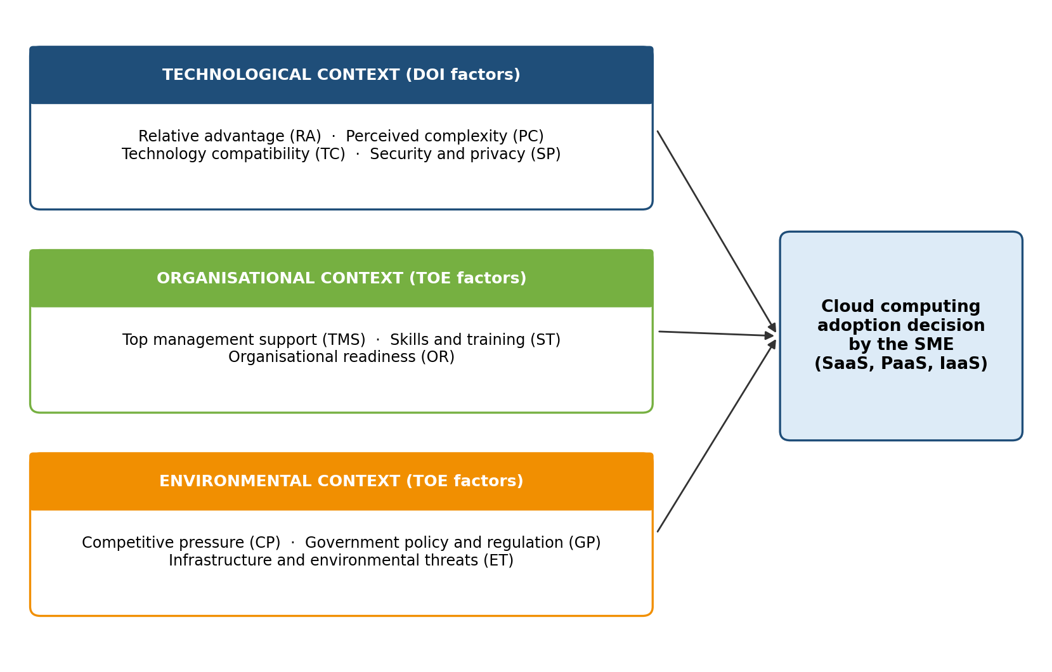
Figure 2.1: Theoretical framework of the study (TOE contexts with DOI technology factors)
Source: Researcher, adapted from Tornatzky and Fleischer (1990)
Technological context (DOI factors)
Relative advantage (RA). RA is the degree to which cloud computing is perceived as better than the existing on-premises alternative, for example through lower cost, scalability and flexibility (Ilahi et al., 2024:58). Organisations are more inclined to adopt technologies that offer clear benefits, and cost savings is the adoption factor reported most often for SMEs (Jayeola et al., 2022:226).
Perceived complexity (PC). PC is the degree to which cloud services are seen as difficult to understand, set up and use. Lower complexity makes adoption easier. Complexity was the most important factor affecting cloud integration among Malaysian SMEs (Al-Sharafi et al., 2023:1) and is listed among the main obstacles for SMEs (Mkhize et al., 2025:2).
Technology compatibility (TC). TC is the extent to which cloud services fit the existing systems, workflows and practices of the organisation (Tornatzky & Fleischer, 1990). Compatibility was significant in 79.3% of the studies reviewed by Jayeola et al. (2022:239).
Security and privacy (SP). SP is the extent to which the organisation trusts that data held by a cloud provider are protected and remain under its control, including where the data are stored. It is the most researched factor in SME cloud adoption (Jayeola et al., 2022:234), and server location was the strongest predictor of adoption in one study (Khayer et al., 2020b:1).
Organisational context (TOE factors)
Top management support (TMS). TMS is the commitment of the owner-manager or senior managers to provide the vision, resources and encouragement that adoption requires. It was significant in 82.1% of the studies reviewed by Jayeola et al. (2022:239).
Skills and training (ST). ST refers to the technical knowledge, competencies and training available to the organisation to select, implement and use cloud services. Digital literacy and technical skills are lacking among African SMEs (Mhlongo et al., 2024:1446), and technical expertise plays a vital role in adoption by South African SMEs (Mudzamba et al., 2022:1).
Organisational readiness (OR). OR is the preparedness of the organisation to adopt and use the technology effectively. It includes financial resources, IT infrastructure and openness to change. Organisational readiness significantly influenced adoption among Indonesian MSMEs (Aligarh et al., 2023:1).
Environmental context (TOE factors)
Competitive pressure (CP). CP is the pressure an organisation feels from competitors, trading partners and its industry to adopt a technology in order to remain competitive (Sithole & Ruhode, 2021:285). It includes the tendency to imitate what similar organisations do (Adjei et al., 2021:1).
Government policy and regulation (GP). GP covers the policies, incentives and regulations through which government facilitates or constrains adoption. In South Africa this includes POPIA, whose provisions only partly apply to cloud computing (Mohlameane & Ruxwana, 2020:7).
Infrastructure and environmental threats (ET). ET refers to external conditions and risks in the operating environment that the organisation cannot control, such as limited broadband, unreliable electricity, economic instability and cyberattacks (Mhlongo et al., 2024:1446; Abubakar et al., 2014:7; Ognjanović et al., 2024:1).

2.3 Technological Factors Influencing Cloud Adoption
Within the technological context, relative advantage represents the primary driver of cloud adoption, defined as the degree to which an innovation is perceived as superior to existing traditional infrastructure (Tornatzky & Fleischer, 1990:152). Global empirical studies consistently demonstrate that when SME managers recognize that cloud configurations lower IT costs, improve operational efficiency, and enhance team collaboration, their adoption intention rises significantly (Ilahi et al., 2024:57; Aligarh et al., 2023:5). However, a sharp contradiction emerges in the South African literature. An empirical study of 230 SMEs in the Polokwane Municipality found that local business owners frequently do not perceive any relative advantage in cloud migration, viewing it as an unnecessary, complex expense (Mokwena & Fatoki, 2024). This conflict indicates that relative advantage is not an inherent feature of cloud technology but depends heavily on prior digital literacy and IT awareness among SME executives (Mkhize et al., 2025:14; Sithole & Ruhode, 2021:296).
Furthermore, compatibility and complexity serve as major technological determinants. Compatibility assesses how seamlessly cloud solutions integrate with an enterprise’s existing business workflows, culture, and legacy systems (Al-Dwairi et al., 2018:2). If an SME relies on highly customized, on-premises legacy databases that cannot connect to modern cloud environments, the resultant incompatibility leads to severe cost inflation and project failure (Mkhize et al., 2025:12). Complexity, representing the perceived difficulty of configuring and managing cloud services, acts as a primary barrier (Al-Dwairi et al., 2018:2; Skafi et al., 2020:140). While simple SaaS products present low complexity, configuring IaaS and PaaS environments demands advanced IT capabilities. Lacking internal IT personnel, South African SMEs frequently reject cloud adoption due to fear of technical complexity (Al-Dwairi et al., 2018:2; Mkhize et al., 2025:14). Data security and POPIA compliance represent the final, critical technological barrier in South Africa. Unlike developed economies where security is treated as a manageable technical factor, South African SME owners view data security as an absolute barrier due to deep mistrust of remote, third-party storage (Jayeola et al., 2022:228).
This is heavily exacerbated by POPIA (Act 4 of 2013), which came into full enforcement in July 2021 and mandates strict penalties for non-compliant cross-border transfers of personal data (Mohlameane & Ruxwana, 2020:4; Modisane & Jokonya, 2021:58). Because global cloud vendors use international data centers, local SMEs without specialized legal counsel choose to remain on obsolete on-premises systems to avoid regulatory violations (Mohlameane & Ruxwana, 2020:7; Kondo et al., 2022:255).

2.4 Organisational Factors Influencing Cloud Adoption
Within the organizational context, top management support represents the most critical determinant of adoption success (Tornatzky & Fleischer, 1990:152). In small enterprises characterized by highly centralized, flat managerial structures, the personal attitude and digital literacy of the business owner dictate the adoption trajectory (Abu Bakar et al., 2024:556; Abubakar et al., 2014:12). If the owner actively supports digital transformation, they can successfully allocate necessary resources and overcome internal resistance to change. However, if leadership is risk-averse, lacks basic IT awareness, or views cloud services merely as a financial expenditure, the enterprise remains locked in obsolete operational models (Abu Bakar et al., 2024:556; Abubakar et al., 2014:12; Sithole & Ruhode, 2021:296). Crucially, financial resource readiness acts as a primary filter. While CSPs market the cloud as a cost-saving tool, the initial migration costs, including internet bandwidth upgrades, data migration consultant fees, dual-system subscription costs, and staff training—represent an insurmountable barrier for resource-constrained South African SMEs (McKinsey & Company, 2024:4; Jayeola et al., 2022:232; Mkhize et al., 2025:52).
The foremost organizational barrier in South Africa is the acute digital skills shortage and absence of dedicated IT personnel (Mkhize et al., 2025:14; Mhlongo et al., 2024:1445). Large enterprises maintain internal IT departments to manage complex systems, but typical South African SMEs are managed by self-taught owners who completely lack formal technical training (Mkhize et al., 2025:14). Lacking internal technical expertise, these businesses are unable to evaluate SLA contracts, manage data migration pipelines, or troubleshoot connectivity issues, thereby escalating their reliance on expensive external consultants and severely inflating the total cost of ownership (Ilahi et al., 2024:57; Mkhize et al., 2025:14; Mhlongo et al., 2024:1445).

2.5 Environmental Factors Influencing Cloud Adoption
Within the environmental context, competitive pressure from digitally-enabled rivals serves as a major external catalyst, pushing SMEs to adopt cloud services to maintain market share and improve customer engagement (Jayeola et al., 2022:233; Abu Bakar et al., 2024:556). However, the intensity of this pressure is highly unequal: while urban SMEs face intense, immediate pressure from tech-dense competitors and digital platforms, rural enterprises operate in less competitive localized markets, reducing their perceived urgency to adopt cloud solutions (Sithole & Ruhode, 2021:296). Furthermore, government and vendor support represents a major institutional deficit in South Africa. While the DSBD has drafted policies aimed at accelerating SMME digitization, ground-level implementation and affordable technical training remain highly limited (DSBD, 2023:15). Local technology vendors also focus their support on large, high-revenue corporate clients, leaving small businesses with minimal guidance to navigate complex integration issues (Jayeola et al., 2022:237; Abubakar et al., 2014:10).

Crucially, utility infrastructure constraints specifically persistent electricity supply disruptions (load shedding) and cellular connectivity gaps—expose a fundamental difference between South African and global research (Adane, 2021:6; Mhlongo et al., 2024:1446). Global TOE-based studies typically assume stable electricity and mature broadband networks as a given. In South Africa, however, load shedding frequently deactivates cellular base stations and local business routers, rendering cloud-hosted applications completely inaccessible (Adane, 2021:6; Mhlongo et al., 2024:1447). This critical vulnerability forces South African SMEs to maintain expensive hybrid or fully on-premises backups, thereby completely neutralizing the financial advantages of cloud configurations (Sithole & Ruhode, 2021:290; Adane, 2021:6; Mhlongo et al., 2024:1447).

2.6 Critical Synthesis of Literature

To systematically map the landscape of empirical research and identify theoretical points of convergence and divergence, Table 1 presents a comparative summary of key TOE-based cloud adoption studies.

Table 2.1: Critical Reviews on Related Studies of Cloud Adoption Studies
Author(s) & Year | Country / Scope | Methodology | Main Empirical Findings | TOE Dimension(s) Covered
Aligarh et al. (2023) | Indonesia | Quantitative Survey | Perceived relative advantage and technological compatibility are the strongest predictors of cloud adoption, which directly enhances MSME operational performance. | Technological, Organisational
Abu Bakar et al. (2024:556) | Malaysia | Quantitative Survey | Competitive pressure and active top management support represent the most influential drivers of cloud computing adoption intent among service-sector SMEs. | Organisational, Environmental
Al-Dwairi et al. (2018) | Jordan | Quantitative Survey | Technological compatibility is the primary facilitator, whereas high architectural complexity acts as the dominant technological inhibitor to adoption. | Technological
Mokwena & Fatoki (2024) | South Africa (Polokwane) | Quantitative Survey | High data costs, severe technical expertise shortages, and POPIA compliance anxieties act as severe barriers, resulting in low cloud adoption. | Technological, Environmental
Mkhize et al. (2025:14) | Sub-Saharan Africa | Systematic Review | Inadequate digital skills, a critical shortage of specialized IT personnel, and high mobile data costs represent the most significant barriers. | Organisational

2.7 Research Gap
A critical evaluation of Table 1 reveals several significant research gaps in the existing body of cloud computing adoption literature. Firstly, the vast majority of TOE-based studies have been conducted within highly stable developing or developed economies (such as Portugal, Malaysia, and Jordan), where a continuous national electricity supply and mature, well-supported legal compliance systems are assumed—conditions that do not reflect the South African context (Adane, 2021:7; Sithole & Ruhode, 2021:282). Secondly, South African scholarship remains highly fragmented, frequently evaluating load shedding, POPIA compliance, and digital skills deficits in isolation rather than through an integrated, systematic theoretical lens (Adane, 2021:7; Mohlameane & Ruxwana, 2020:4). No evidence-based, contextualized cloud adoption framework specifically tailored to South Africa’s unique regulatory, infrastructural, and economic conditions currently exists. This study directly addresses these gaps by applying a complete TOE framework to synthesize existing empirical research and propose a practical, context-sensitive adoption framework.

3. Research Methodology

3.1 Introduction
This chapter describes how the study was conducted. The researcher adopted a qualitative systematic literature review (SLR) and followed the PRISMA 2020 reporting guideline (Page et al., 2021). The chapter explains the research philosophy and approach, the data sources and search strategy, the inclusion and exclusion criteria, the selection process, quality appraisal, data extraction and analysis, and ethical considerations.

3.2 Ethics
Because this study utilizes secondary, publicly available scientific literature, no human participants were subjected to direct intervention. An ethical clearance exemption was granted by the CPUT Departmental Ethics Committee. Secondary data governance was maintained by ensuring accurate citation, preventing plagiarism via SafeAssign verification, and storing all project files in an organized digital directory in compliance with CPUT open data archiving guidelines.

3.3 Delineation and Scope
The scope of this study is strictly delineated to formal South African SMEs employing fewer than 200 individuals, in strict compliance with the thresholds established by the National Small Business Act (Act 102 of 1996, as amended) (DSBD, 2023:14). Geographically, the study focuses on factors relevant to the South African business environment, specifically local regulatory frameworks (POPIA) and infrastructural conditions (load shedding). Technologically, the review evaluates configurations across the three primary service models (SaaS, PaaS, IaaS) and deployment options (public, private, hybrid), using only the standard constructs of the TOE framework (relative advantage, compatibility, complexity, management support, readiness, competitive pressure, regulatory support, and infrastructure constraints).

3.4 Project Timeline
To ensure the timely and successful completion of the research within the academic year, the project progresses according to a highly structured schedule.
Table 3.1: Presents the detailed Project Gantt Schedule and Milestone Breakdown.
Academic Phase | Core Activities & Operations | Target Completion Date | Deliverable & Output
Phase 1: Proposal | Draft and submit research proposal, secure department ethical clearance exemption. | June 2026 | Approved Proposal V3 & Exemption Form
Phase 2: Search | Execute Boolean search query across eight databases, remove duplicates, abstract screen. | August 2026 | PRISMA Search Log & Screener Sheet
Phase 3: Appraisal | Retrieve full-text papers, evaluate study quality using MMAT checklist, extract data. | September 2026 | Quality Appraisal Matrix
Phase 4: Synthesis | Conduct thematic analysis of extracted factors, design the contextualized TOE framework. | September 2026 | Draft Cloud Adoption Framework
Phase 5: Reporting | Write final technical report, prepare academic poster, and deliver oral presentation. | October 2026 | Final Technical Report & Presentation

4. Data Collection

4.1 Justification for Systematic Literature Review
This study relied exclusively on secondary data, that is, findings already reported in published studies. A systematic literature review (SLR) was therefore the appropriate design. It allowed evidence from separate studies, regions and sectors to be identified, appraised and combined in a transparent and repeatable manner (Tranfield et al., 2003:208; Page et al., 2021). Primary surveys of cloud adoption in South Africa tend to be limited to one municipality or sector, whereas a review makes it possible to compare their findings and to see where they converge or conflict (Jayeola et al., 2022:226).
The data were qualitative in nature. The study was concerned with the reasons, perceptions and contextual conditions that influence adoption decisions, and not with new statistical measurement. Reported findings and authors' interpretations were treated as textual data that could be coded and synthesised into themes (Thomas & Harden, 2008:4).

4.2 Search Strategy and Databases
The researcher searched eight electronic databases on 15 August 2026: Scopus, Web of Science, IEEE Xplore, ACM Digital Library, ScienceDirect, SpringerLink, Google Scholar and MDPI. The core Boolean search string applied to titles, abstracts and keywords was:
("cloud computing adoption" OR "cloud adoption") AND ("SMEs" OR "small and medium enterprises" OR "SMMEs" OR "small businesses") AND ("Technology Organisation Environment" OR "TOE framework") AND ("South Africa" OR "developing economy" OR "developing nations")
The string was adapted to the syntax of each database (Appendix C), with filters for English-language, peer-reviewed publications from 2020 to 2026. This first search produced 342 records but, after screening and verification of each record against its full text, only a small set of usable studies remained. Because this evidence base was too thin for a rigorous review, additional articles were sought. On 5 October 2026 the researcher ran a supplementary search with the same core terms in Google Scholar and followed candidate titles to the publishers' sites. The supplementary search identified 39 further candidate records. Four older foundational studies were identified by checking the reference lists of included reviews. Table 4.1 shows the results of both searches.
Table 4.1: Search results by database, including the additional articles sought
Source | Search date | Records identified | Duplicates removed | Records screened | Excluded (title/abstract) or not retrieved | Full texts assessed
Scopus | 15 Aug 2026 | 45 | 10 | 35 | 20 | 15
Web of Science | 15 Aug 2026 | 22 | 8 | 14 | 8 | 6
IEEE Xplore | 15 Aug 2026 | 18 | 5 | 13 | 7 | 6
ACM Digital Library | 15 Aug 2026 | 12 | 2 | 10 | 6 | 4
ScienceDirect | 15 Aug 2026 | 38 | 15 | 23 | 12 | 11
SpringerLink | 15 Aug 2026 | 25 | 12 | 13 | 8 | 5
Google Scholar | 15 Aug 2026 | 150 | 45 | 105 | 85 | 20
MDPI | 15 Aug 2026 | 32 | 5 | 27 | 18 | 9
Sub-total: database search |  | 342 | 102 | 240 | 164 | 76
Supplementary search (additional articles sought) | 5 Oct 2026 | 39 | 0 | 39 | 11 | 28
Backward citation searching | Sept 2026 | 4 | 0 | 4 | 0 | 4
Total |  | 385 | 102 | 283 | 175 | 108

Source: PRISMA search log, cloud_adoption_lit_tracker_v3.xlsx

4.3 Inclusion and Exclusion Criteria
The researcher applied the criteria in Table 4.2. Studies published from 2020 onwards were targeted so that the findings reflect current conditions, including the full enforcement of the Protection of Personal Information Act (POPIA) from July 2021. Four earlier studies (2014–2018) were retained as foundational evidence on SMEs in developing economies because later studies build on them. Records from the supplementary search that were published before 2020 were excluded.
Table 4.2: Inclusion and exclusion criteria
Criterion | Inclusion | Exclusion
Publication date | 2020–2026; four earlier foundational studies identified by citation searching | Other pre-2020 publications
Language | English | Non-English
Publication type | Peer-reviewed journal articles and conference papers | Editorials, blogs, news, dissertations, preprints and other non-peer-reviewed reports
Topic | Adoption of cloud computing (including cloud accounting, cloud ERP and SaaS) by SMEs, using or discussing TOE-type factors | Non-cloud ICT; studies with no adoption factors
Context | South Africa and other developing or emerging economies; global SME reviews; a small number of TOE studies from markets where SME cloud adoption is still emerging | Studies of mature cloud markets (e.g. USA, UK, Japan)
Access | Full text available and verified against the tracker | Full text not available

4.4 Article Selection Process
Selection followed the PRISMA 2020 flow shown in Figure 4.1 (Page et al., 2021). The database search identified 342 records, and 102 duplicates were removed. The titles and abstracts of the remaining 240 records were screened and 164 were excluded because they did not address cloud adoption by SMEs. The full texts of 76 reports were assessed, and 46 were excluded because they were published before 2020, focused on large enterprises, did not address cloud computing or TOE factors, or were not peer-reviewed. Thirty reports passed this stage. When each record was verified against its PDF during data extraction, 15 were removed because the full text had not been retained, the wrong file had been retrieved, or the record could not be traced. Fifteen studies from the database search were therefore retained.
Through the other methods, 43 records were identified (39 from the supplementary search and 4 from citation searching). Eleven could not be retrieved because of access restrictions, and 32 full texts were assessed. Seven were excluded: three were published before 2020, two were not peer-reviewed, and two did not use TOE-type factors. Twenty-five studies were retained. In total, 40 studies were included in the synthesis: 15 from the database search and 25 from other methods.
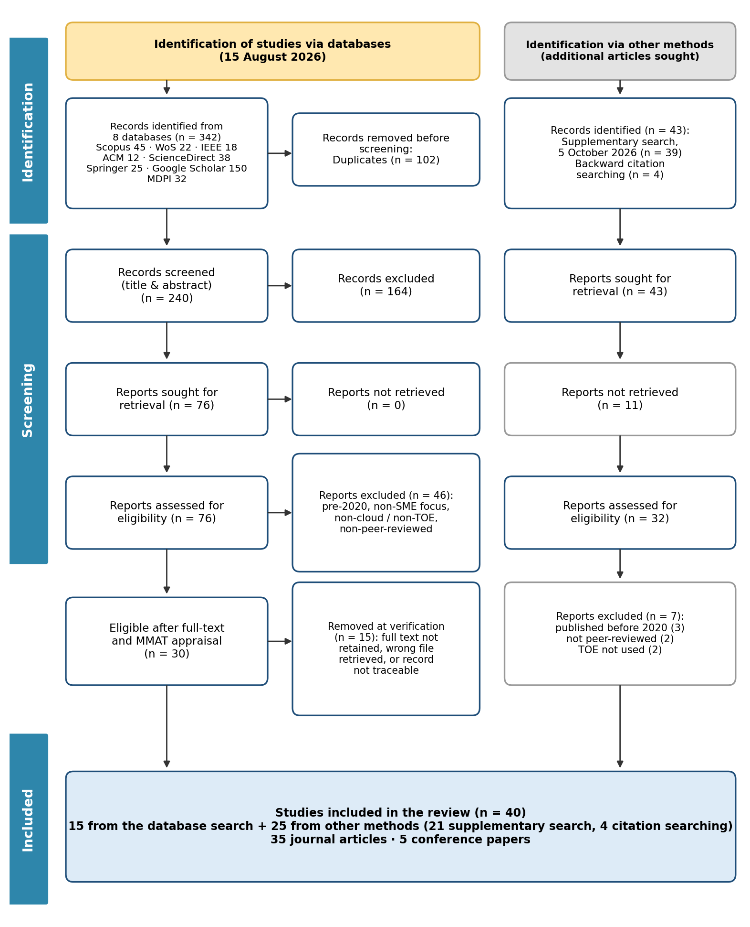
Figure 4.1: PRISMA 2020 flow diagram of the study selection process (n = 40)
Source: Adapted from Page et al. (2021) using the researcher's search log
The drop from 385 identified records to 40 included studies shows how strictly the criteria were applied: every study used in the analysis had to be in scope, peer-reviewed and verified against its source.

4.5 Quality Appraisal
Each included study was appraised with the Mixed Methods Appraisal Tool (MMAT) version 2018 (Hong et al., 2018:285). Two screening questions were followed by five design-specific criteria, each scored "Yes", "No" or "Can't tell". Studies meeting four or five criteria were rated High, three Moderate, and fewer than three Low. Thirty-seven studies (92.5%) were rated High and three (7.5%) Moderate (Appendix B). The three Moderate studies were two conceptual papers, for which the data and analysis criteria could not be judged, and one descriptive survey. No study was rated Low, so none was excluded on quality grounds, but the Moderate studies were used to support themes and not as the sole evidence for any finding.

4.6 Data Extraction
The researcher extracted data into a standardised matrix in the literature tracker. For each study the matrix recorded the bibliographic details, source, publication channel, research method, country, the TOE dimension addressed, the key finding with a verbatim quotation and its PDF page number, and whether POPIA or electricity reliability was discussed (Appendix A). To support the frequency analysis in Section 5.2.6, the full text of each study was searched for terms linked to twelve TOE factors, and a factor was recorded as discussed where it was mentioned at least three times outside the reference list.

4.7 Data Analysis
The extracted data were analysed in two steps. First, the included studies were described by year, source, publication channel, research method and geographic focus, in the same way that the demographic profile of participants is reported in a survey. Second, the findings were analysed through the three-stage thematic synthesis of Thomas and Harden (2008:4): line-by-line coding of the findings, grouping of codes into descriptive themes, and interpretation of these into analytical themes. The coding was anchored in the theoretical framework in Section 2.2.1 but remained open to factors the framework does not anticipate, such as regulation, server location and electricity reliability. The themes were then organised under the research question each one answers.

4.8 Rigour
Rigour was supported by a documented search string, explicit inclusion criteria, a logged selection process, MMAT appraisal, and verification of every extracted quotation against the text of the source PDF. Where included studies disagreed, the disagreement was reported and not resolved by selection.

4.9 Ethical Considerations
The study used only published literature, and no human participants were involved. An ethics exemption was obtained from the CPUT departmental ethics committee. Ethical practice was maintained through accurate citation, plagiarism checking, disclosure of AI tool use, and storage of all 40 articles for submission to Blackboard as the subject guide requires.

5. Findings and Discussion

5.1 Introduction
This chapter presents the findings of the review. Section 5.2 describes the key attributes of the 40 included studies. Section 5.3 presents the thematic analysis, organised by the research questions raised in Chapter 1. Section 5.4 discusses the findings against the literature reviewed in Chapter 2, and Section 5.5 answers the research questions.

5.2 Key Publication Attributes of the Included Studies
Table 5.1 summarises the 40 included studies by region, showing how many studies each region contributed, which research designs they used, and what they mainly found. Each study has an ART code that matches the file name in the Articles folder; the study-by-study list with the verbatim extract from each study is given in Appendix A and in the literature tracker.
Table 5.1: Summary of the included studies by region, research design and main findings (n = 40)
Region | Studies | % | Countries (n) | Research designs | Main findings
South Africa | 6 | 15.0% | South Africa | 4 survey; 1 mixed; 1 qualitative | Low adoption and limited knowledge; regulatory uncertainty (POPIA); skills and preparation gaps; divided evidence on management support
Rest of Africa | 6 | 15.0% | Nigeria (2), continental review (1), Somalia (1), Ghana (1), Uganda (1) | 4 survey; 1 review; 1 qualitative | Infrastructure, power and skills constraints; institutional pressure; adopters optimistic about benefits
Asia | 13 | 32.5% | Indonesia (4), Malaysia (3), Bangladesh (2), Sri Lanka (1), Pakistan (1), Thailand (1), Nepal (1) | 11 survey; 2 conceptual | Relative advantage, top management support and complexity tested with SEM; cloud accounting growing
Middle East | 6 | 15.0% | Jordan (2), Saudi Arabia (2), Lebanon (1), Bahrain (1) | 4 survey; 1 qualitative; 1 mixed | TOE factors and institutional pressures; security and reliability concerns
Europe | 3 | 7.5% | Portugal (1), Turkey (1), Montenegro (1) | 2 survey; 1 mixed | Compatibility and convenience; attitudes shaped by security incidents
Global reviews | 6 | 15.0% | — | 6 review | Cost savings most cited driver; security and initial cost most cited barriers
Total | 40 | 100% | 21 countries + global reviews | 25 survey; 7 review; 3 mixed; 3 qualitative; 2 conceptual

Source: Researcher's data extraction matrix

5.2.1 Publication representation by year
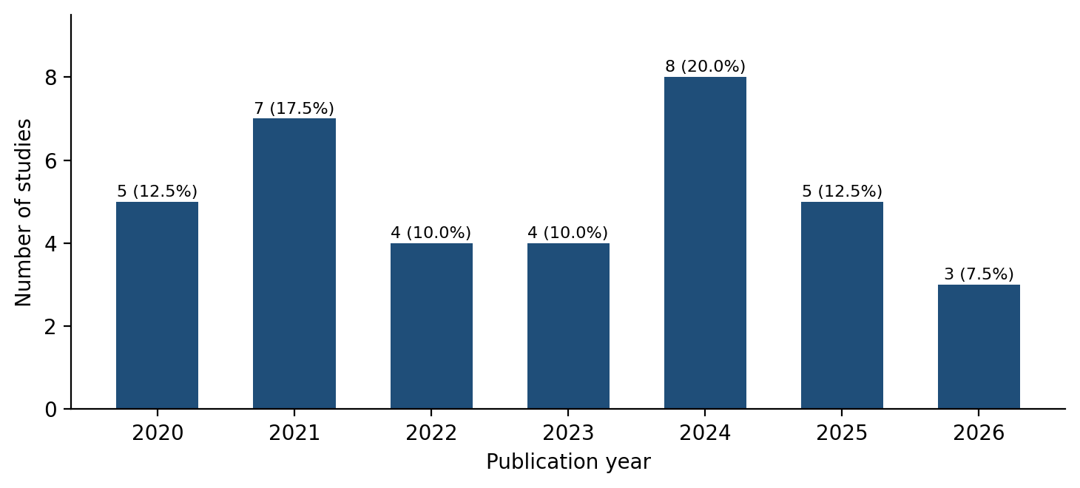
Figure 5.1: Distribution of included studies by publication year, 2020–2026 (n = 36)
Source: Researcher's analysis of included studies (n = 40)
Figure 5.1 shows the 36 studies (90.0% of the 40) published in the target window of 2020 to 2026. The largest group appeared in 2024 (8 studies, 20.0%), followed by 2021 (7 studies, 17.5%) and 2020 and 2025 (5 studies each, 12.5%). Three studies (7.5%) were published in 2026, which shows that the review captured very recent work. This concentration reflects the growth of the field: Ahmad et al. (2025:1) found that publications on cloud adoption by SMEs peaked at 140 articles in 2024. The four foundational studies published before 2020 (Abubakar et al., 2014; Nuskiya, 2017; Al-Dwairi et al., 2018; Salleh et al., 2018) are not shown in the figure, because they fall outside the target window and were retained only as background evidence. Because nine in ten studies appeared after 2020, the findings largely reflect the period after POPIA came into force and after the COVID-19 pandemic accelerated digital adoption.

5.2.2 Publication representation by source
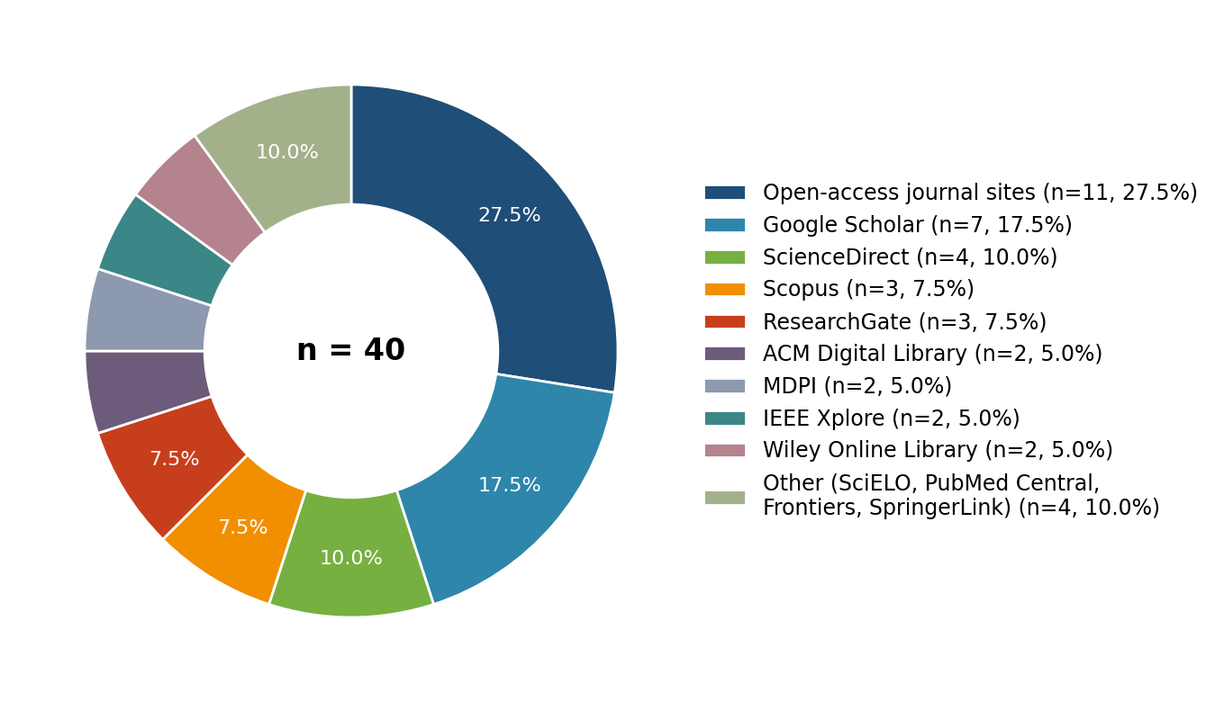
Figure 5.2: Distribution of included studies by source database or platform
Source: Literature tracker, Source Database column (n = 40)
The included studies came from a wide range of sources (Figure 5.2). Eleven studies (27.5%) were retrieved from the websites of open-access journals, and seven (17.5%) through Google Scholar. ScienceDirect supplied four (10.0%), Scopus and ResearchGate three each (7.5%), and ACM Digital Library, MDPI, IEEE Xplore and Wiley Online Library two each (5.0%). The remaining four came from SciELO, PubMed Central, Frontiers and SpringerLink. The large share of open-access journal sites and Google Scholar is explained by the topic: much of the research on SMEs in developing economies is published in regional open-access journals that the subscription databases do not always index. Relying on subscription databases alone would have under-represented African and Asian evidence.

5.2.3 Publication representation by channel
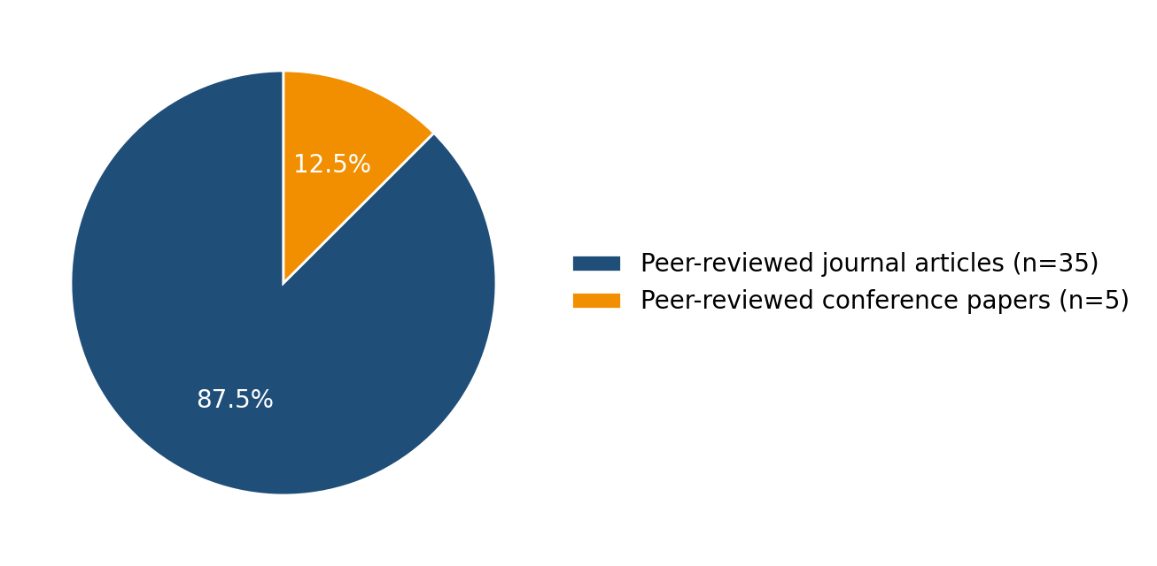
Figure 5.3: Distribution of included studies by publication channel
Source: Researcher's analysis of included studies (n = 40)
Figure 5.3 shows that 35 studies (87.5%) were peer-reviewed journal articles and 5 (12.5%) were peer-reviewed conference papers (Al-Dwairi et al., 2018; Salleh et al., 2018; Sithole & Ruhode, 2021; Modisane & Jokonya, 2021; Sastararuji et al., 2021). No theses, reports or other non-peer-reviewed sources were included, in line with the exclusion criteria. The strong journal base supports the credibility of the synthesis.

5.2.4 Publication representation by research method
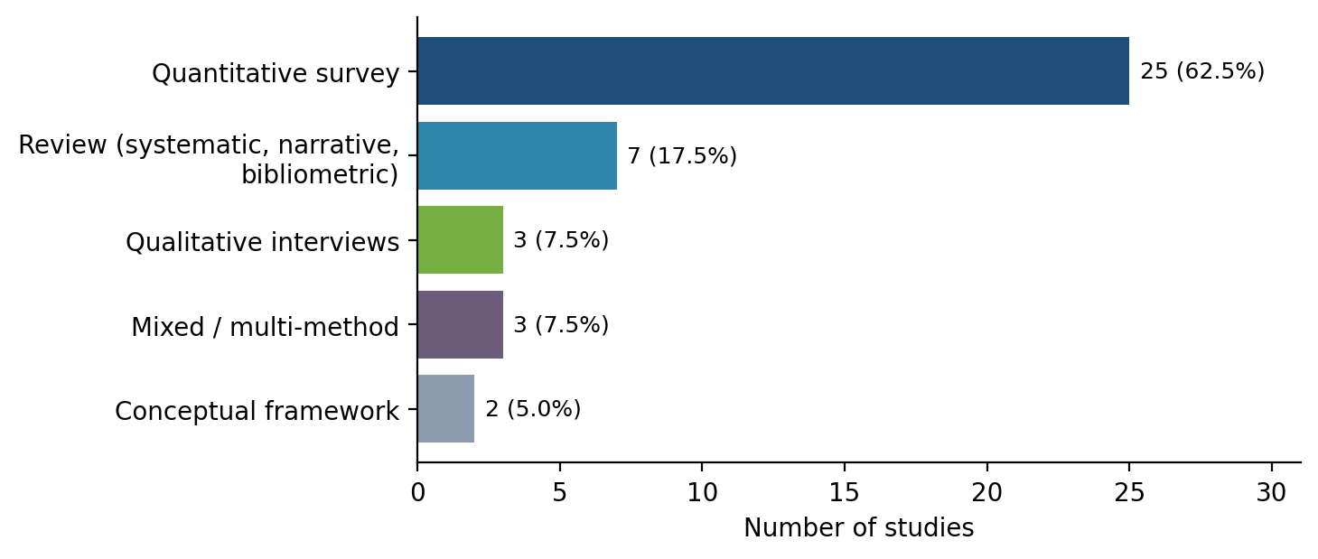
Figure 5.4: Distribution of included studies by research method
Source: Researcher's analysis of included studies (n = 40)
Quantitative surveys dominated the evidence base (25 studies, 62.5%). Most tested TOE constructs with structural equation modelling, for example Aligarh et al. (2023), Al-Sharafi et al. (2023), Mujalli et al. (2024) and Subramaniam and Teh (2026). Reviews formed the second group (7 studies, 17.5%), including three systematic reviews (Salleh et al., 2018; Jayeola et al., 2022; Mkhize et al., 2025). Qualitative interview studies (Abubakar et al., 2014; Al-Dwairi et al., 2018; Mudzamba et al., 2022) and mixed or multi-method studies (Mohlameane & Ruxwana, 2020; Alamri & Alzahrani, 2024; Ognjanović et al., 2024) contributed three studies each (7.5%), and two studies (5.0%) proposed conceptual frameworks. The dominance of surveys means the review is strong on which factors are statistically related to adoption. The small number of qualitative studies means that the reasons behind owner-managers' decisions are less well explained, which is a limitation of the field and not only of this review.

5.2.5 Publication representation by geographic focus
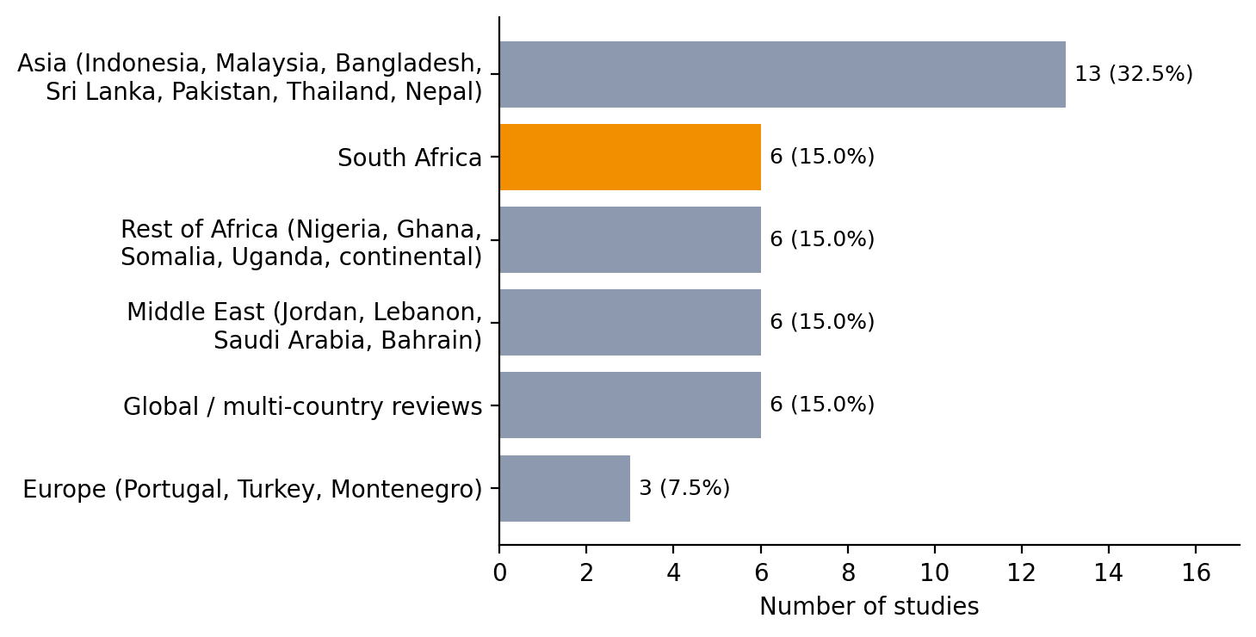
Figure 5.5: Distribution of included studies by geographic focus
Source: Researcher's analysis of included studies (n = 40)
Figure 5.5 shows a strong emphasis on developing and emerging economies. Asia contributed the most studies (13, 32.5%), led by Indonesia (4) and Malaysia (3), which agrees with the observation by Jayeola et al. (2022:226) that Asia records the highest number of studies. South Africa was the most represented single country, with six studies (15.0%): Mohlameane and Ruxwana (2020), Sithole and Ruhode (2021), Modisane and Jokonya (2021), Mudzamba et al. (2022), Mokwena and Fatoki (2024) and Morema et al. (2026). The rest of Africa (Nigeria, Ghana, Somalia, Uganda and one continental review), the Middle East and the global reviews each contributed six studies (15.0%), and Europe three (7.5%). Twelve studies in total (30.0%) concern Africa. Although South Africa is the best-represented country, six studies is still a modest base, which is why the review drew on comparable economies to interpret the South African findings.

5.2.6 Coverage of TOE factors
Table 5.2 summarises how many of the 40 studies addressed each TOE context substantially (● ten or more relevant mentions), partially (◐ three to nine) or to a limited extent (○ fewer than three), and lists the most discussed factors in each context. Figure 5.6 shows the frequency of every factor.
Table 5.2: Summary of TOE context coverage across the 40 studies (number of studies)
TOE context / issue | ● Substantial | ◐ Partial | ○ Limited or none | Most discussed factors (number of studies)
Technological | 36 | 4 | 0 | Security & privacy (38); Relative advantage / cost savings (31); Complexity / ease of use (25)
Organisational | 34 | 4 | 2 | IT skills & expertise (31); Organisational / technology readiness (28); Cost of adoption / finance (27)
Environmental | 35 | 4 | 1 | Infrastructure & connectivity (36); Government & regulatory support (31); Competitive pressure (26)
POPIA discussed | 1 | — | 39 | Mohlameane & Ruxwana (2020) only
Electricity / load shedding | 2 | 1 (brief) | 37 | Abubakar et al. (2014); Morema et al. (2026); brief mention in Skafi et al. (2020)

Source: Keyword-assisted coding of full texts (n = 40)
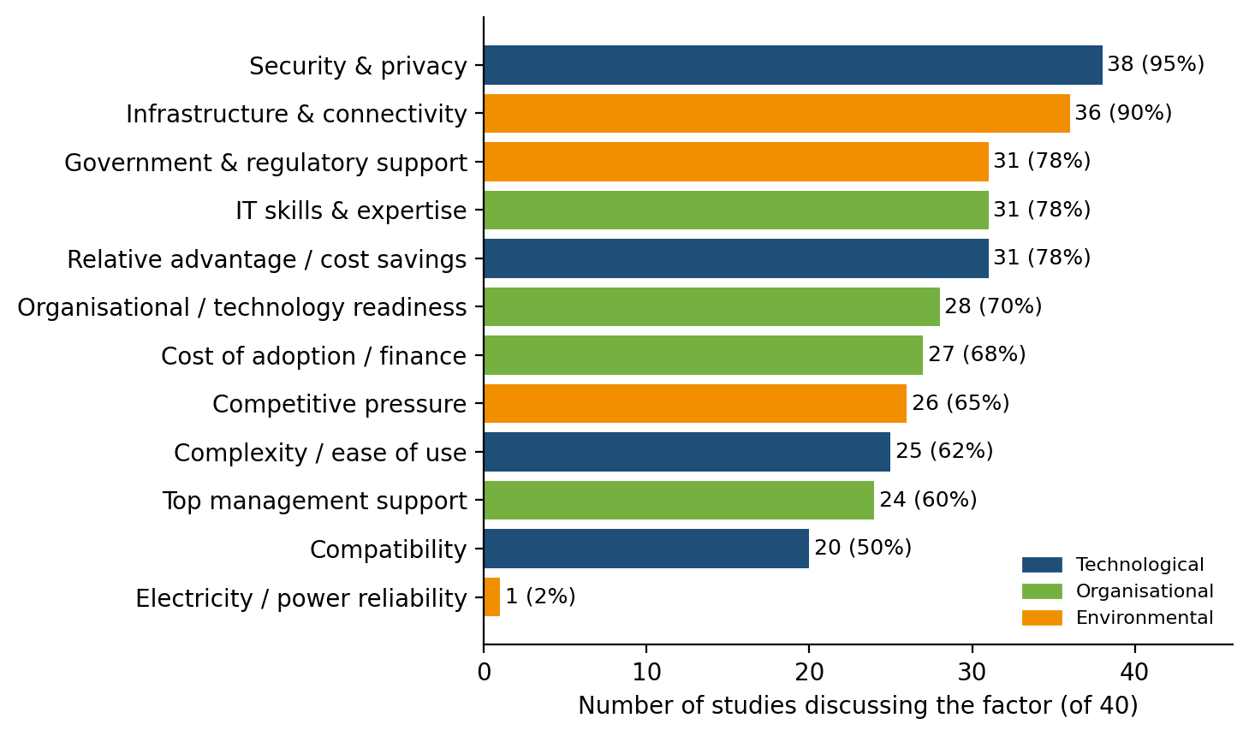
Figure 5.6: Frequency of TOE factors across the included studies
Source: Keyword-assisted coding of full texts (n = 40)
Security and privacy was the most widely discussed factor (38 of 40 studies), followed by infrastructure and connectivity (36). Relative advantage, IT skills and government or regulatory support were each discussed in 31 studies. Organisational readiness (28), cost of adoption (27), competitive pressure (26), complexity (25) and top management support (24) formed a middle group, and compatibility (20) was the least discussed of the standard constructs. Two findings stand out for South Africa. Only one study discussed POPIA (Mohlameane & Ruxwana, 2020), and only one discussed electricity reliability at length (Abubakar et al., 2014), with one further study naming load shedding as an operational reality (Morema et al., 2026). The two conditions that are most specific to South Africa are therefore the least researched.

5.3 Thematic Analysis
This section presents the themes that emerged from the 40 studies under each research question. The main research question asked what technological, organisational and environmental factors influence cloud adoption among South African SMEs, and how these factors can be addressed through a contextualised framework. The themes follow the constructs of the theoretical framework in Section 2.2.1 (Table 5.3). Under each theme, the authors are compared to show where they agree and where they differ.
Table 5.3: Research questions, objectives and emergent themes
Research question | Objective | Emergent themes
RQ1: Technological factors | Objective 1 | Theme 1.1 Relative advantage and perceived value  Theme 1.2 Security, privacy and data sovereignty  Theme 1.3 Complexity and compatibility
RQ2: Organisational factors | Objective 2 | Theme 2.1 Top management support  Theme 2.2 Skills and training  Theme 2.3 Organisational readiness and finance
RQ3: Environmental factors | Objective 2 | Theme 3.1 Competitive and institutional pressure  Theme 3.2 Government policy and regulation  Theme 3.3 Infrastructure and environmental threats
RQ4: Contextualised framework | Objective 3 | Relationships among Themes 1–3; provider and intermediary support; proposed framework

5.3.1 Research Question 1: Technological Factors
RQ1: What are the technological factors that hinder or enable cloud computing adoption among South African SMEs? Three themes emerged.
Theme 1.1: Relative advantage and perceived value
Relative advantage emerged as the most frequently confirmed enabler. Sithole and Ruhode (2021:282) found that relative advantage is an important factor for South African SMMEs considering the cloud. This was supported in Indonesia, where Aligarh et al. (2023:1) and Gui et al. (2020:1) both found that relative advantage had a positive effect on adoption, and in Malaysia, where Al-Sharafi et al. (2023:1) found relative advantage and cost reduction significant among 415 SMEs. Khayer et al. (2020b:1) and Mujalli et al. (2024:1) reported the same in Bangladesh and Saudi Arabia, and Ali et al. (2023:66) found cost savings significant in Somalia. The reviews quantify the pattern: Mkhize et al. (2025:1) report cost savings in 76% of the 90 studies they analysed, and Jayeola et al. (2022:226) identify cost savings as the most important adoption factor.
Not all authors agree, however. Hamzah et al. (2023:442) found that relative advantage did not significantly affect the adoption of cloud accounting, and Andanawarih et al. (2026:463) found that it worked against adoption among Indonesian MSMEs. Subramaniam and Teh (2026:1) found relative advantage significant but cost-effectiveness not significant (β = 0.054, p = 0.164), and suggested that Malaysian SMEs now prioritise capability over cost. These newer studies suggest that the cost argument is losing force where subscriptions are cheap or subsidised, and that advantage has to be understood as more than cost.
The South African evidence adds a condition. Mokwena and Fatoki (2024:4625) found that the majority of SMEs in Polokwane had not yet adopted cloud computing and still relied on traditional IT services, with limited knowledge of the alternatives. Mudzamba et al. (2022:1) likewise found that knowledge among SMEs plays a vital role in the adoption process. A benefit that is not known cannot drive a decision. Relative advantage is therefore an enabler only where owner-managers are aware of it, which links this theme to the organisational context.
Theme 1.2: Security, privacy and data sovereignty
Security and privacy was discussed in 38 of the 40 studies, more than any other factor, which agrees with Jayeola et al. (2022:234) that it is the most researched factor in the field. Mokwena and Fatoki (2024:4628) identified security as the greatest barrier among Polokwane SMEs, and Mkhize et al. (2025:1) report that data security risks affected 45% of SMEs. Khayer et al. (2020a:64) found data security and privacy and perceived trust to be significant predictors, Hamzah et al. (2023:442) found security significant, and Subramaniam and Teh (2026:1) found that security assurance significantly influenced adoption. Nosheen et al. (2025:32) describe SaaS adoption in Pakistan as beset by data privacy, legal compliance and security concerns, and Ognjanović et al. (2024:1) show that cyberattacks on national e-services shaped Montenegrin SMEs' attitudes.
Two studies qualify this picture. Ali et al. (2023:66) found that security concerns had no significant relationship with adoption in Somalia, and Abubakar et al. (2014:1) found that Nigerian SMEs that had already adopted the cloud were less concerned with security, privacy and data loss. Security concern therefore appears strongest before adoption and weaker among firms with experience.
A related finding concerns where data are kept. Khayer et al. (2020b:1) found that server location was the most significant predictor of cloud adoption in their neural network analysis, ahead of relative advantage and top management support. In South Africa this concern is tied to regulation. Mohlameane and Ruxwana (2020:7) found that over 90% of their participants viewed the POPI Act as a policy that has an impact on cloud computing, and that its conditions only partly apply to cloud services. This study interprets the combination of the two findings as sovereignty friction: an SME that does not know where its data will be stored, or whether storing it abroad is lawful, has a reason to delay.
Theme 1.3: Complexity and compatibility
Complexity was discussed in 25 studies and compatibility in 20. Al-Sharafi et al. (2023:1) found complexity to be the most important of all factors affecting cloud integration (normalised importance 89.14%), ahead of cost reduction and government support. Skafi et al. (2020:79169) found complexity significant in Lebanon, Sayginer and Ercan (2021:141) found that top management support and complexity together explained 29.8% of the adoption decision in Turkey, and Hamzah et al. (2023:442) and Mujalli et al. (2024:1) found complexity significant for cloud accounting. Subramaniam and Teh (2026:1) again differ: complexity was not significant among Malaysian SMEs (β = 0.042, p = 0.276), which suggests that complexity matters less as cloud services become easier to use.
On compatibility, Picoto et al. (2021:278) found that convenience, compatibility and organisational confidence were significant antecedents of cloud use, Mujalli et al. (2024:1) found compatibility significant, and Jayeola et al. (2022:239) found it significant in 79.3% of the studies they reviewed. Hamzah et al. (2023:442), in contrast, found that compatibility did not significantly affect adoption. Complexity also depends on the service model: only SaaS removes the need to manage infrastructure (Ahmad et al., 2025:2). For SMEs without IT staff, the technological barrier is lowest when adoption begins with SaaS.

5.3.2 Research Question 2: Organisational Factors
RQ2: What organisational factors influence the cloud computing adoption decisions of South African SMEs? Three themes emerged.
Theme 2.1: Top management support
Top management support was the most consistently significant organisational factor. It was significant in Indonesia (Gui et al., 2020:1; Hamzah et al., 2023:442; Andanawarih et al., 2026:463), Malaysia (Al-Sharafi et al., 2023:1), Bangladesh (Khayer et al., 2020b:1), Saudi Arabia (Mujalli et al., 2024:1), Turkey (Sayginer & Ercan, 2021:141), Somalia (Ali et al., 2023:66), Lebanon (Skafi et al., 2020:79169) and Sri Lanka (Nuskiya, 2017:1). Jayeola et al. (2022:239) found it significant in 82.1% of reviewed studies, and Mkhize et al. (2025:1) report it as a driver in 68%.
The South African evidence is divided. Sithole and Ruhode (2021:288) found no significant relationship between top management support and adoption opportunities (χ² = 1.728, p = 0.189). Morema et al. (2026), in contrast, found top management support to be a strong predictor of cloud ERP adoption among logistics SMEs in Ekurhuleni (β = 0.466) and argue that adoption should be treated as a leadership decision. The difference may lie in measurement: Sithole and Ruhode measured management support through access to finance, whereas Morema et al. measured leadership commitment. Buhari et al. (2022:5119) point in the same direction, naming lack of encouragement and lack of executive sponsorship among the challenges facing Nigerian SMEs. The synthesis suggests that management support drives adoption when it means informed commitment, and not when it means only willingness to pay.
Theme 2.2: Skills and training
Skills and expertise were discussed in 31 studies. In South Africa, Mudzamba et al. (2022:1) found that technical expertise plays a vital role in cloud adoption, that SMEs that recognise this often use intermediaries, and that SMEs generally do not carry out comprehensive preparatory activities and consequently fail in their adoption. Modisane and Jokonya (2021:784) identify the lack of ICT skills as part of the resource constraints facing SMMEs, and Mhlongo et al. (2024:1446) report that digital literacy and technical skills are lacking among African SMEs. Buhari et al. (2022:5119) name poor training as a barrier in Nigeria.
Where skills are present they enable adoption. Skafi et al. (2020:79169) found prior IT experience positively related to adoption, Khayer et al. (2020a:64) found absorptive capacity significant, Mujalli et al. (2024:1) found employee capability significant, Subramaniam and Teh (2026:1) found IT competency significant, and Aligarh et al. (2023:1) and Khayer et al. (2020b:1) found computer self-efficacy significant. Only Hamzah et al. (2023:442) found IT competence not significant, which may reflect how little skill packaged cloud accounting requires. Skills therefore affect adoption in both directions: firms that lack them delay or fail, and firms that have them adopt.
Theme 2.3: Organisational readiness and finance
Organisational readiness was discussed in 28 studies and cost of adoption in 27. Aligarh et al. (2023:1) found organisational readiness significant, Nuskiya (2017:1) found technology readiness significant, and Hamzah et al. (2023:442) and Mujalli et al. (2024:1) found adequate organisational resources significant. Ali et al. (2023:66) found firm size significant, which implies that the smallest firms are least ready. Finance is two-sided. Cloud computing removes the need for capital investment in hardware (Shetty & Panda, 2021:1), yet initial cost concerns affected 48% of SMEs in the studies reviewed by Mkhize et al. (2025:1), and Abu Bakar et al. (2024:554) name financial constraints and maintenance costs as challenges. Mokwena and Fatoki (2024:4625) link SME failure in South Africa to the non-availability of financial and IT resources. The shift from capital to operational expenditure is attractive in principle, but only to firms that can budget for subscriptions, connectivity and support.

5.3.3 Research Question 3: Environmental Factors
RQ3: What environmental factors shape SME decisions to adopt or avoid cloud-based systems in South Africa? Three themes emerged.
Theme 3.1: Competitive and institutional pressure
Competitive pressure was discussed in 26 studies. Aligarh et al. (2023:1) and Andanawarih et al. (2026:463) found competitor pressure and the bandwagon effect significant, and Hamzah et al. (2023:442) found competitive pressure, pressure from trading partners and coercive pressure significant. Subramaniam and Teh (2026:1) found competitive pressure and industry influence significant, and Mujalli et al. (2024:1) found mimetic and normative pressures significant. In Ghana, Adjei et al. (2021:1) found that mimetic, coercive and normative pressures together explained 27% of the variance in cloud adoption, with mimetic pressure, that is copying what similar organisations do, contributing most. Ali et al. (2023:66) found no significant effect of competitive pressure in Somalia, where few competitors have adopted. Sithole and Ruhode (2021:285, 287) tested competitive and trading-partner pressure in South Africa, but no South African study found it to be the dominant factor. The evidence suggests that external pressure works once adoption is visible among peers, and is weak where the market is still at an early stage.
Theme 3.2: Government policy and regulation
Government and regulatory factors were discussed in 31 studies. Outside South Africa, government support mostly appears as an enabler: Al-Sharafi et al. (2023:1) found it significant and ranked third in importance (73.37%), Ali et al. (2023:66) found regulatory support significant, Hamzah et al. (2023:442) found government support significant, and Gui et al. (2020:1) argue that improvement in adoption should come from government policy and incentives. Skafi et al. (2020:79169) found that a lack of government initiatives was negatively related to adoption.
In South Africa the same factor appears as a constraint. Sithole and Ruhode (2021:282) found that government and regulatory support is perceived as a barrier, and Mohlameane and Ruxwana (2020:5–7) explain part of the reason: there is no cloud-specific legislative framework, and existing laws, including the POPI Act, fit cloud computing only partly. Shetty and Panda (2021:1) identify policy as an under-researched outlier in the literature. Government policy can therefore push in either direction: where support and clear rules exist it enables adoption, and where rules are unclear it holds adoption back.
Theme 3.3: Infrastructure and environmental threats
Infrastructure and connectivity were discussed in 36 studies. Mhlongo et al. (2024:1445–1446) identify limited internet infrastructure and low rural broadband penetration as barriers across Africa, Modisane and Jokonya (2021:784) cite the lack of ICT infrastructure among South African SMMEs, Skafi et al. (2020:79169) found poor infrastructure negatively related to adoption, and Nosheen et al. (2025:32) describe infrastructural deficiencies and limited access to IT resources in Pakistan. External shocks also matter: Ognjanović et al. (2024:1) show how the COVID-19 pandemic and cyberattacks shifted SME attitudes, and Sastararuji et al. (2021:1) note that the pandemic brought cloud adoption to the forefront for SMEs.
Electricity reliability is the least evidenced threat. Abubakar et al. (2014:7, 9–10) found that Nigerian SMEs used cloud back-ups because of power problems, and that the cloud partly offset the cost of running electricity-hungry hardware on site. Morema et al. (2026) observe that existing adoption models do not account for the operational realities of load shedding and limited ICT capital that characterise logistics SMEs in Ekurhuleni. Unreliable power may therefore work in two directions: it can deter adoption by threatening access, and it can encourage adoption by removing local hardware. No included study measured the effect of load shedding on cloud use. This is reported as an evidence gap and not as an established finding.

5.3.4 Research Question 4: A Contextualised Framework
RQ4: How can a framework, informed by the TOE lens, be structured to guide South African SMEs in adopting cloud computing in a manner that is affordable, legally compliant and operationally appropriate?
Read together, the themes show that the three contexts are linked. Uncertainty about security, server location and POPIA (Theme 1.2) reinforces owner-manager caution (Theme 2.1). Limited skills (Theme 2.2) mean that relative advantage is not recognised (Theme 1.1) and that preparation is skipped. Weak or unclear government support and unreliable infrastructure (Themes 3.2 and 3.3) leave that caution unchallenged. Several studies also point to a factor outside the three standard contexts: support from providers and intermediaries. Sastararuji et al. (2021:1) add vendor and owner dimensions to the TOE contexts, Khayer et al. (2020b:1) found cloud provider influence significant, Hamzah et al. (2023:442) found provider support significant, and Mudzamba et al. (2022:1) found that South African SMEs that succeed often rely on intermediaries.
The proposed framework (Figure 5.7) therefore has four parts: a South African context layer; the three TOE contexts with the factors confirmed by the review; an enabling layer of provider and intermediary support; and the adoption decision. Table 5.4 links each part to the evidence and to a practical response.
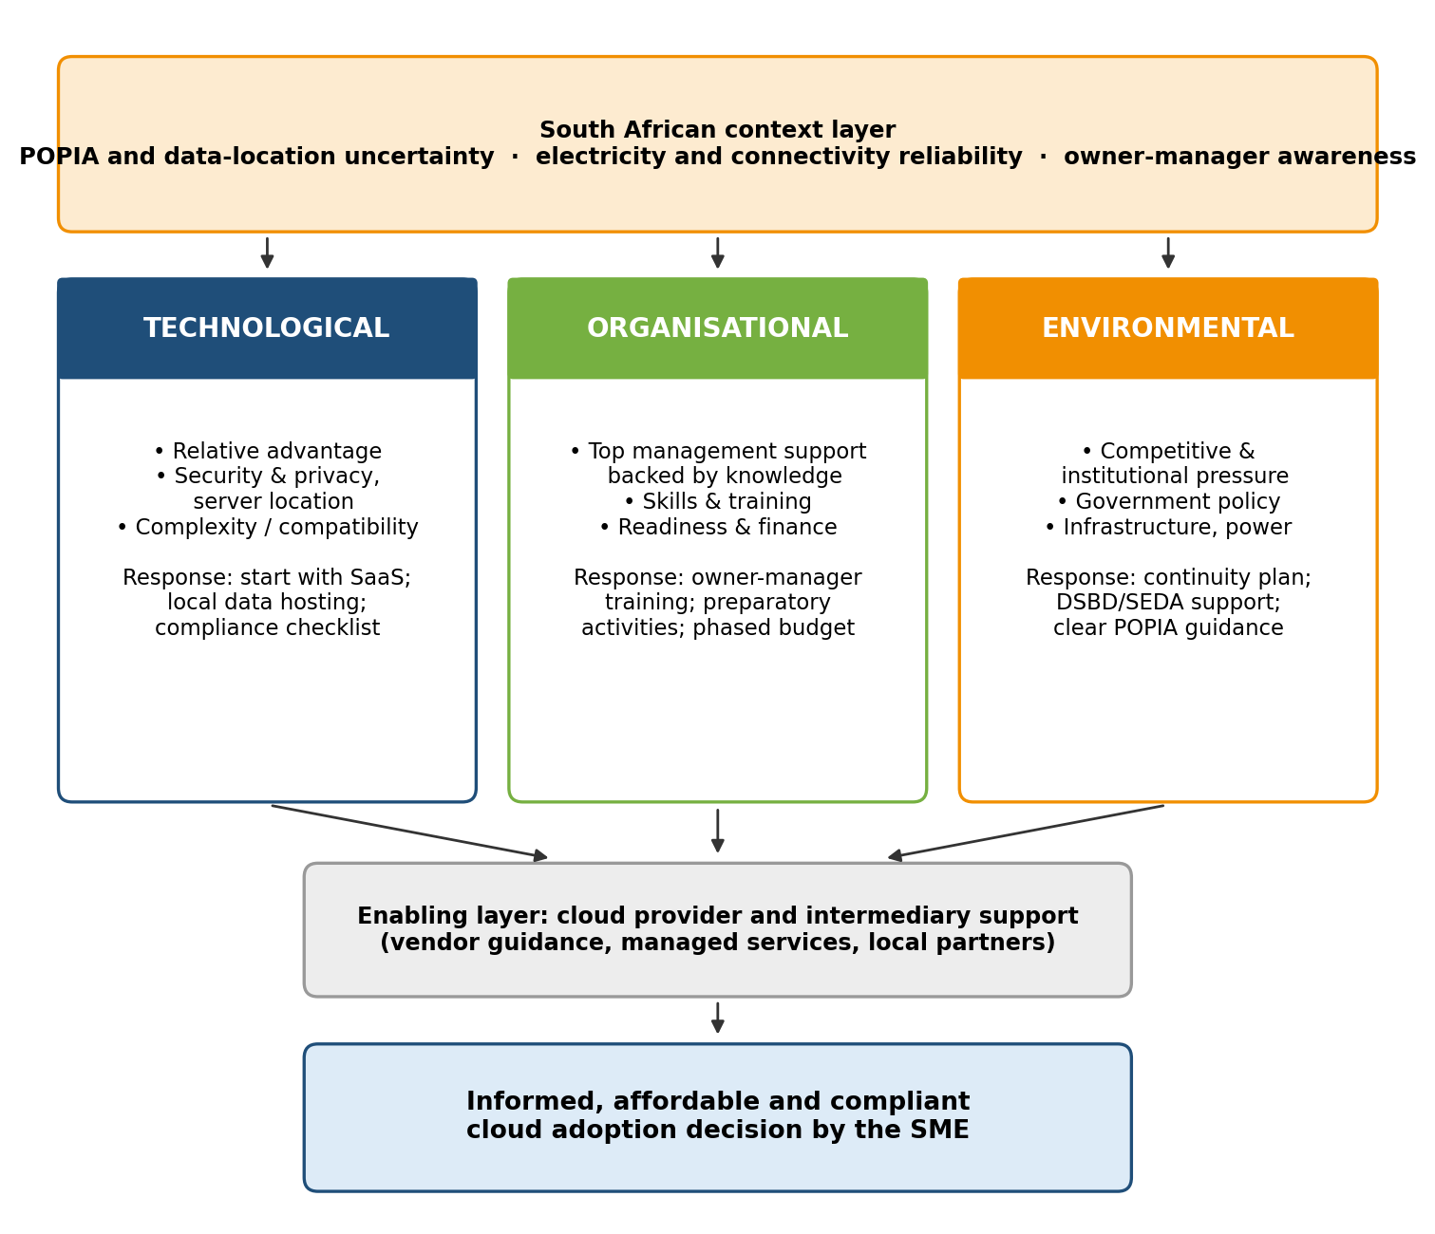
Figure 5.7: Proposed contextualised TOE framework for South African SMEs
Source: Researcher's synthesis of Themes 1.1–3.3
Table 5.4: Contextualised TOE framework matrix
Framework element | Evidence from the review | South African constraint | Proposed response (researcher's proposal)
Technological | Relative advantage (31 studies); security and privacy (38); complexity (25) | Low awareness of benefits; POPIA only partly fits cloud; data stored abroad | Start with SaaS; prefer locally hosted data for personal information; use a compliance checklist before migrating
Organisational | Top management support (24); skills (31); readiness (28) | Owner-manager decides alone; skills deficit; preparation skipped; cash constraints | Owner-manager awareness training; preparatory activities before adoption; phased operational budget
Environmental | Government and regulation (31); infrastructure (36); competitive pressure (26) | Support perceived as a barrier; rural connectivity; load shedding unstudied | Continuity plan (UPS, dual connectivity); DSBD and SEDA digital support; plain-language POPIA guidance
Provider and intermediary support | Vendor, provider and intermediary support significant in four studies | SMEs lack in-house expertise to deal with providers | Managed service partners; transparent rand-based pricing; local support

The responses in the final column are the researcher's proposals derived from the themes; they are not findings reported by the included studies. The framework is a decision aid that shows SME owners where their readiness is weakest. It has not been empirically validated.

5.4 Discussion of Findings Against the Literature
This section compares the findings with the literature reviewed in Chapter 2 and the theoretical framework in Section 2.2.1.
Technological context. The literature review presented relative advantage as the primary driver of adoption (Ilahi et al., 2024:58). The findings confirm this for most settings, but the most recent studies show that it is no longer universal: relative advantage or cost was not significant in three studies published between 2023 and 2026 (Hamzah et al., 2023; Andanawarih et al., 2026; Subramaniam & Teh, 2026). The literature also treated complexity as a main barrier, and the findings agree, with Al-Sharafi et al. (2023) ranking it first. The findings extend the literature on security by showing that the location of data, and not only its protection, shapes decisions (Khayer et al., 2020b), which connects directly to the POPIA concerns raised in Chapter 2 (Mohlameane & Ruxwana, 2020).
Organisational context. The literature review identified top management support as the most critical organisational determinant, and the findings support this across ten countries. The findings add nuance for South Africa: support was not significant when measured as access to finance (Sithole & Ruhode, 2021) but was the strongest predictor when measured as leadership commitment (Morema et al., 2026). The skills shortage described in Chapter 2 (Mkhize et al., 2025; Mhlongo et al., 2024) is confirmed, and Mudzamba et al. (2022) add that South African SMEs fail because they skip preparation and lack expertise, not because the technology is unsuitable.
Environmental context. The literature review suggested that competitive pressure is a major external catalyst. The findings support this where adoption is already visible among peers, and the Ghanaian evidence on mimetic pressure (Adjei et al., 2021) helps to explain why: SMEs copy what others do. The findings also confirm the institutional deficit described in Chapter 2: government support enables adoption in Malaysia, Somalia and Indonesia but is perceived as a barrier in South Africa. On infrastructure, the literature review made strong statements about load shedding, but the review found that this is asserted far more often than it is studied. Only two of the 40 studies mention electricity or load shedding in any depth.
Theoretical implications. The findings support the TOE premise that adoption results from the interaction of three contexts (Tornatzky & Fleischer, 1990), and the DOI constructs of relative advantage, complexity and compatibility remain useful. However, the findings show two limits of the standard model for South Africa. It does not capture data location and regulatory fit, and it does not include provider and intermediary support, which four studies found significant. The proposed framework adds both.

5.5 Answering the Research Questions
• RQ1 (technological factors). Relative advantage enables adoption where owner-managers are aware of it, although its effect is weakening in newer studies. Security and privacy concerns, together with uncertainty about where data are stored and how POPIA applies, are the main inhibitors. Complexity is a significant barrier that can be reduced by starting with SaaS.
• RQ2 (organisational factors). Top management support is the most consistent driver, provided it means informed commitment and not only willingness to pay. A lack of skills, training and preparation is the most consistent barrier, and the smallest and least resourced firms are the least ready.
• RQ3 (environmental factors). Competitive and institutional pressure encourages adoption once peers have adopted. Government support enables adoption elsewhere but is perceived as a barrier in South Africa because regulation is unclear. Infrastructure constrains adoption, and the effect of load shedding remains unmeasured.
• RQ4 (framework). A contextualised TOE framework should add a South African context layer (POPIA and data location, electricity and connectivity, owner-manager awareness) and an enabling layer of provider and intermediary support to the three standard contexts, and should link each to a practical response.
Together these answers address the main research question: cloud adoption among South African SMEs is shaped less by the technology itself than by awareness, skills, leadership commitment, regulatory clarity and infrastructure, and these factors must be addressed together.

6. Conclusion and Recommendations

6.1 Summary of the Study
This study adopted a qualitative systematic literature review to examine why cloud computing adoption among South African SMEs remains limited. Following PRISMA 2020, the researcher identified 385 records from eight databases, a supplementary search and citation searching, and included 40 verified studies published between 2014 and 2026. The studies were profiled by year, source, channel, method and geography, and their findings were synthesised thematically through a framework that combines the TOE contexts with DOI technology factors.

6.2 Recommendations
• For SME owner-managers: treat cloud adoption as a leadership decision. Begin with low-complexity SaaS applications, carry out preparatory activities (needs assessment, data audit, staff training) before migrating, choose providers that host personal information locally, and plan fallback access for critical systems.
• For cloud providers and managed service providers: offer transparent, fixed-price contracts in rand, state clearly where data are stored, and position managed services and local support as a way to close the skills gap that small firms report.
• For policy makers (DSBD, SEDA and the Information Regulator): fund digital literacy programmes aimed at owner-managers, publish plain-language guidance on how POPIA applies to cloud services and cross-border storage, and consider incentives of the kind that enabled adoption in other developing economies.
• For researchers: measure management support as informed commitment and not as access to finance, and include data location and provider support in adoption models.

6.3 Contribution of the Study
Theoretical contribution. The study extends the TOE framework for the South African SME context in two ways: it adds a context layer covering POPIA and data location, electricity and connectivity reliability, and owner-manager awareness; and it adds provider and intermediary support as an enabling layer. It also shows that the effect of relative advantage and complexity is weakening in recent studies, and that top management support depends on how it is defined.
Practical contribution. The framework and matrix give SME owners, providers and policy makers a structured tool for identifying where adoption support is most needed. Methodological contribution. The study provides a verified, traceable evidence base of 40 studies, each linked to its source file and a verbatim quotation, which other researchers can reuse.

6.4 Limitations
The study relied on secondary data, so its findings depend on the scope and quality of the 40 included studies. Only six studies examined South Africa directly, only one discussed POPIA and only two discussed electricity or load shedding. Twenty-six records that passed earlier stages could not be used because their full texts were not available or could not be verified. Four included studies come from high-income countries and four were published before 2020, which the reader should bear in mind. The factor frequencies in Figure 5.6 show how often a factor was discussed, not its statistical strength. The MMAT appraisal was carried out by a single researcher. The framework has not been tested with SMEs.

6.5 Future Research
Future research should validate the framework through surveys or case studies of South African SMEs, measure directly how load shedding and connectivity disruptions affect cloud use, and examine how SMEs interpret POPIA and data location when choosing providers. Qualitative interviews with owner-managers would help to explain when management support turns into adoption, and longitudinal studies such as that of Ognjanović et al. (2024) would show how attitudes change over time.

References
Abu Bakar, M.R., Mat Razali, N.A., Ishak, K.K., Ismail, M.N. & Tengku Sembok, T.M. 2024. Adoption of Industry 4.0 with cloud computing as a mediator: evaluation using TOE framework for SMEs. JOIV: International Journal on Informatics Visualization, 8(2):554–563.
Abubakar, A.D., Bass, J.M. & Allison, I. 2014. Cloud computing: adoption issues for sub-Saharan African SMEs. The Electronic Journal of Information Systems in Developing Countries, 62(1):1–17.
Adane, M. 2021. Cloud computing adoption: opportunities and challenges for small, medium and micro enterprises in South Africa. arXiv preprint, arXiv:2108.10079.
Adjei, J.K., Adams, S. & Mamattah, L. 2021. Cloud computing adoption in Ghana; accounting for institutional factors. Technology in Society, 65: 101583.
Ahmad, C.S., Mahomed, A.S.B. & Hashim, H. 2025. Cloud computing adoption in SMEs: exploring IaaS, PaaS and SaaS through a bibliometric study. International Journal of Academic Research in Business and Social Sciences, 15(1). http://dx.doi.org/10.6007/IJARBSS/v15-i1/24452
Al-Dwairi, R.M., Al-Tweit, N. & Zyout, K. 2018. Factors influencing cloud-computing adoption in small and medium e-commerce enterprises in Jordan. In Proceedings of the International Conference on Internet and e-Business (ICIEB 2018), Singapore, 25–27 April 2018. New York: ACM.
Al-Sharafi, M.A., Iranmanesh, M., Al-Emran, M., Alzahrani, A.I., Herzallah, F. & Jamil, N. 2023. Determinants of cloud computing integration and its impact on sustainable performance in SMEs: an empirical investigation using the SEM-ANN approach. Heliyon, 9: e16299.
Alamri, N. & Alzahrani, S. 2024. Navigating the clouds: an exploratory research of cloud computing adoption in Saudi Arabia's small and medium enterprises. Engineering, Technology & Applied Science Research, 14(6):17859–17869. https://doi.org/10.48084/etasr.8435
Ali, A.F., Hassan, A.A., Abdullahi, H.O. & Abdulah, R.H. 2023. Analyzing the factors influencing the adoption of cloud computing by SMEs using the SEM approach. International Journal of Advanced and Applied Sciences, 10(7):66–79.
Aligarh, F., Sutopo, B. & Widarjo, W. 2023. The antecedents of cloud computing adoption and its consequences for MSMEs' performance: a model based on the Technology-Organization-Environment (TOE) framework. Cogent Business & Management, 10(2): Article 2220190. https://doi.org/10.1080/23311975.2023.2220190
Andanawarih, P.P., Mila, S. & Novitaningrum, D. 2026. Antecedents of cloud accounting adoption and its consequences on SME performance: a TOE framework approach. Amkop Management Accounting Review, 6(1):463–481.
Barigye, G.B. 2025. Determinants of cloud computing adoption in small and medium enterprises (SMEs): a case of RENU, Uganda. Metropolitan Journal of Academic Pedagogical Research, 4(2):425–444.
Buhari, B.A., Muhammad, B.S., Bodinga, B.A. & Sifawa, M.D. 2022. Adoption of cloud computing by IT based small and medium scale enterprises in Northwestern Nigeria. International Journal of Advanced Networking and Applications, 13(5):5119–5127.
Davis, F.D. 1989. Perceived usefulness, perceived ease of use, and user acceptance of information technology. MIS Quarterly, 13(3):319–340.
Fatoki, O. 2014. The causes of the failure of new small and medium enterprises in South Africa. Mediterranean Journal of Social Sciences, 5(20):922–927.
FinMark Trust. 2024. FinScope MSME South Africa 2024. Johannesburg: FinMark Trust.
Ghimire, P., Piaralal, S.K., Raghavan, S. & Rethina, V.S. 2024. Exploring sustainability in cloud computing adoption among SMEs in Nepal: a conceptual model. International Journal of Academic Research in Business and Social Sciences, 14(11). http://dx.doi.org/10.6007/IJARBSS/v14-i11/23347
Greiner, R. 2014. Windows Azure IaaS vs. PaaS vs. SaaS. Robert Greiner Blog, 18 March. http://robertgreiner.com/2014/03/windows-azure-iaas-paas-saas-overview/ [12 April 2026].
Gui, A., Fernando, Y., Shaharudin, M.S., Mokhtar, M., Karmawan, I.G.M. & Suryanto. 2020. Cloud computing adoption using TOE framework for Indonesia's micro small medium enterprises. JOIV: International Journal on Informatics Visualization. https://joiv.org/index.php/joiv/article/view/458
Hamzah, A., Suhendar, D. & Arifin, A.Z. 2023. Factors affecting cloud accounting adoption in SMEs. Jurnal Akuntansi, 27(3):442–464.
Homan, J. & Beránek, L. 2023. Factors influencing cloud computing adoption by SMEs in the Czech Republic: an empirical analysis using Technology-Organization-Environment framework. Acta Informatica Pragensia, 12(2):296–310.
Hong, Q.N., Fàbregues, S., Bartlett, G., Boardman, F., Cargo, M., Dagenais, P., Gagnon, M.-P., Griffiths, F., Nicolau, B., O'Cathain, A., Rousseau, M.-C., Vedel, I. & Pluye, P. 2018. The Mixed Methods Appraisal Tool (MMAT) version 2018 for information professionals and researchers. Education for Information, 34(4):285–291.
Ilahi, S., Mohammed, R., Souissi, A., Hamati, M.Y.N. & Smida, R. 2024. Small and medium enterprises (SMEs): key factors affecting the adoption of cloud computing. Saudi Journal of Humanities and Social Sciences, 9(2):55–62. https://doi.org/10.36348/sjhss.2024.v09i02.004
Jayeola, O., Sidek, S., Abd Rahman, A., Mahomed, A.S.B. & Hu, J. 2022. Cloud computing adoption in small and medium enterprises (SMEs): a systematic literature review and directions for future research. International Journal of Business and Society, 23(1):226–243.
Khayer, A., Jahan, N., Hossain, M.N. & Hossain, M.Y. 2020a. The adoption of cloud computing in small and medium enterprises: a developing country perspective. VINE Journal of Information and Knowledge Management Systems, 51(1):64–91.
Khayer, A., Talukder, M.S., Bao, Y. & Hossain, M.N. 2020b. Cloud computing adoption and its impact on SMEs' performance for cloud supported operations: a dual-stage analytical approach. Technology in Society, 60: 101225.
Kondo, N., Oosterwyk, G. & Van Belle, J.-P. 2022. Factors influencing the adoption of Infrastructure as a Service by South African small and medium-sized enterprises. World Conference on Information Systems and Technologies, 253–262.
Li, B. & Kumar, S. 2022. Managing software-as-a-service: pricing and operations. Production and Operations Management, 31(6):2588–2608.
Lutfi, A. 2022. Understanding the intention to adopt cloud-based accounting information system in Jordanian SMEs. The International Journal of Digital Accounting Research, 22:47–70.
McKinsey & Company. 2024. Africa's leap ahead into cloud: opportunities and barriers. McKinsey Digital, January.
Mell, P. & Grance, T. 2011. The NIST definition of cloud computing. NIST Special Publication 800-145. Gaithersburg: National Institute of Standards and Technology.
Mhlongo, N.Z., Usman, F.O., Odeyemi, O., Ike, C.U., Elufioye, O.A. & Daraojimba, A.I. 2024. Reviewing the impact of cloud computing on small and medium enterprises in Africa. International Journal of Science and Research Archive, 11(1):1444–1451.
Milhem, M., Ayyash, M.M., Ateeq, A., Alzaghal, Q., Alzoraiki, M., Almuraqab, N.A.S. & Almeer, S. 2025. An integrated adoption model of cloud computing-based human resource management by SMEs in developing countries: evidence from Bahrain. Frontiers in Sustainability, 6: 1503423.
Mkhize, A., Mokhothu, K.D., Tshikhotho, M. & Thango, B.A. 2025. Evaluating the impact of cloud computing on SME performance: a systematic review. Businesses, 5(2): Article 23.
Modisane, P. & Jokonya, O. 2021. Evaluating the benefits of cloud computing in small, medium and micro-sized enterprises (SMMEs). Procedia Computer Science, 181:784–792.
Mohlameane, M. & Ruxwana, N. 2020. Exploring the impact of cloud computing on existing South African regulatory frameworks. South African Journal of Information Management, 22(1): a1132.
Mokwena, J.H. & Fatoki, O. 2024. Barriers of cloud computing adoption by small and medium enterprises in Polokwane Municipality. Tuijin Jishu/Journal of Propulsion Technology, 45(2):4625–4634.
Morema, T.P., Adeyelure, T.S. & Seaba, T.R. 2026. Cloud ERP adoption in Ekurhuleni's logistics SMEs: a conceptual model. South African Journal of Information Management, 28(1): a2179.
Mudzamba, R., Van der Schyff, K. & Renaud, K. 2022. The challenges of cloud adoption among South African small to medium enterprises: a thematic analysis. The Electronic Journal of Information Systems in Developing Countries, e12235. https://doi.org/10.1002/isd2.12235
Mujalli, A., Wani, M.J.G., Almgrashi, A., Khormi, T. & Qahtani, M. 2024. Investigating the factors affecting the adoption of cloud accounting in Saudi Arabia's small and medium-sized enterprises (SMEs). Journal of Open Innovation: Technology, Market, and Complexity, 10: 100314.
Neves, F.T., Marta, F.C., Correia, A.M.R. & Neto, M.D.C. 2011. The adoption of cloud computing by SMEs: identifying and coping with external factors. XI Conferencia de la Asociación Portuguesa de Sistemas de Información, 1–12.
Ngo Ndjama, J. & Van der Westhuizen, T. 2024. Strategic IT alignment in South African small and medium-sized enterprises: a review. South African Journal of Business Management, 55(1):600–612.
Nosheen, A., Omar, M.A. & Hashim, K.F. 2025. Investigating the determinants of cloud computing-software as a service adoption in Pakistani SMEs from the perspective of SME managers. Journal of Advanced Research Design, 127(1):32–48.
Nuskiya, A.F. 2017. Factors influencing cloud computing adoption by SMEs in eastern region of Sri Lanka. Journal of Information Systems & Information Technology, 2(1).
Ognjanović, I., Šendelj, R., Daković-Tadić, M. & Kožuh, I. 2024. A longitudinal study on the adoption of cloud computing in micro, small, and medium enterprises in Montenegro. Applied Sciences, 14(14): 6387.
Ongowarsito, H., Prabowo, H. & Gaol, F.L. 2022. Adoption readiness assessment model based on SaaS maturity level in SMEs. International Journal of Emerging Technology and Advanced Engineering, 12(4):24–31.
Page, M.J., McKenzie, J.E., Bossuyt, P.M., Boutron, I., Hoffmann, T.C., Mulrow, C.D. et al. 2021. The PRISMA 2020 statement: an updated guideline for reporting systematic reviews. BMJ, 372: n71.
Picoto, W.N., Crespo, N.F. & Carvalho, F.K. 2021. The influence of the technology-organization-environment framework and strategic orientation on cloud computing use, enterprise mobility, and performance. Revista Brasileira de Gestão de Negócios, 23(2):278–300.
Salleh, N.A., Hussin, H. & Suhaimi, M.A. 2018. A systematic literature review of cloud computing adoption and impacts among small medium enterprises (SMEs). In 2018 International Conference on Information and Communication Technology for the Muslim World (ICT4M). Kuala Lumpur: IEEE.
Sastararuji, D., Hoonsopon, D., Pitchayadol, P. & Chiwamit, P. 2021. Cloud accounting adoption in small and medium enterprises: an integrated conceptual framework. In Proceedings of the International Conference on Industrial Engineering and Industrial Management (IEIM 2021). New York: ACM. https://doi.org/10.1145/3447432.3447439
Sayginer, C. & Ercan, T. 2021. Multi-perspective decision-making cloud computing adoption model for small and medium enterprises (SMEs). Emerging Science Journal, 4 (Special Issue):141–153. http://dx.doi.org/10.28991/esj-2021-SP1-010
Shetty, J.P. & Panda, R. 2021. An overview of cloud computing in SMEs. Journal of Global Entrepreneurship Research. https://doi.org/10.1007/s40497-021-00273-2
Sithole, S.S. & Ruhode, E. 2021. Cloud computing adoption: opportunities and challenges for small, medium and micro enterprises in South Africa. In Proceedings of the 1st Virtual Conference on Implications of Information and Digital Technologies for Development, 282–301.
Skafi, M., Yunis, M.M. & Zekri, A. 2020. Factors influencing SMEs' adoption of cloud computing services in Lebanon: an empirical analysis using TOE and contextual theory. IEEE Access, 8:79169–79181.
Small Enterprise Development Agency (SEDA). 2018. SMME Quarterly Update: 1st Quarter 2018. Pretoria: SEDA.
South Africa. Department of Small Business Development (DSBD). 2023. Draft South African small, micro and medium enterprises policy. Pretoria: Government Printer.
Subramaniam, A. & Teh, R. 2026. Accelerating digital transformation: key drivers of cloud computing adoption and firm performance outcomes in Malaysian SMEs. Future Business Journal, 12: 28. https://doi.org/10.1186/s43093-025-00711-7
Thomas, J. & Harden, A. 2008. Methods for the thematic synthesis of qualitative research in systematic reviews. BMC Medical Research Methodology, 8: 45.
Tornatzky, L.G. & Fleischer, M. 1990. The processes of technological innovation. Lexington, MA: Lexington Books.
Tranfield, D., Denyer, D. & Smart, P. 2003. Towards a methodology for developing evidence-informed management knowledge by means of systematic review. British Journal of Management, 14(3):207–222.

Appendix A: Data Extraction Summary (verbatim quotations)
Code | TOE dimension | Verbatim quotation from the source | PDF page | Answers
ART-001 | All three | "relative advantage, organizational readiness, bandwagon effect, competitor pressure, computer self-efficacy, and computer anxiety significantly influence the adoption of cloud computing" | 2 | RQ1–RQ3
ART-002 | Organisational | "is hindered by various challenges such as financial constraints, maintenance costs, and a lack of digital culture and awareness" | 1 | RQ2
ART-003 | Technological | "need, cost, security, and reliability are major factors that impact cloud computing adoption" | 1 | RQ1
ART-004 | Technological | "The results reveal that the majority of SMEs in the study area have not yet adopted cloud computing for running their businesses" | 5 | RQ1, RQ2
ART-005 | All three | "Key adoption drivers include management support (cited by 68% of studies), service quality (56%), and perceived risks (54%)" | 1 | RQ1, RQ2
ART-006 | All three | "relative advantage is an important factor in the consideration of cloud computing adoption by SMMEs, while government and regulatory support is perceived as a barrier" | 1 | RQ1–RQ3
ART-007 | Environmental | "including issues related to infrastructure, data security, and skill gaps" | 1 | RQ2, RQ3
ART-008 | All three | "relative advantage, top management support, technical readiness, and competitive pressure" | 1 | RQ1–RQ3
ART-009 | Technological | "Findings indicate a significant surge in publications, reaching a peak of 140 articles in 2024" | 1 | RQ1
ART-010 | All three | "Asia recorded the highest number of studies, whereas cost savings is the most important adoption factor" | 1 | RQ1, RQ2
ART-011 | Technological | "performance expectancy; effort expectancy; absorptive capacity; data security and privacy; and perceived trust" | 1 | RQ1, RQ2
ART-012 | Environmental | "poor infrastructure and lack of government initiatives) are negatively related to the adoption decision" | 1 | RQ1–RQ3
ART-013 | Technological | "Findings highlight the applicability of influential factors such as" | 1 | RQ1, RQ3
ART-014 | Technological | "The results indicate that convenience, compatibility, and organizational confidence are significant antecedents of the use of cloud computing" | 1 | RQ1, RQ2
ART-015 | Technological | "A total of 39 relevant articles were reviewed" | 1 | RQ1
ART-016 | Organisational | "The significant impact was identified to adopt the cloud computing is top management support and technology readiness" | 1 | RQ2
ART-017 | Environmental | "these SMEs are less concerned with challenges like security, privacy and data loss" | 1 | RQ2, RQ3
ART-018 | All three | "technological context has a positive significant effect on the adoption of cloud computing practices" | 8 | RQ1–RQ3
ART-019 | Environmental | "over 90% of participants viewed the POPI Act as a policy that has an impact on cloud computing" | 7 | RQ1, RQ3
ART-020 | Organisational | "Our findings indicate that technical expertise (i.e., knowledge) amongst SMEs plays a vital role in the cloud adoption process" | 1 | RQ2
ART-021 | All three | "top management support (β = 0.466)" | 7 | RQ2, RQ3
ART-022 | Organisational | "lack of encouragement, poor training, application is missing and lack of executive sponsorship" | 1 | RQ2
ART-023 | Organisational | "top management encouragement and relative advantages have a positive impact on the adoption of cloud computing in MSMEs in Indonesia" | 1 | RQ1, RQ2
ART-024 | All three | "relative advantage, complexity, compatibility, top management support, cost reduction, and government support significantly affect cloud computing integration" | 1 | RQ1–RQ3
ART-025 | Technological | "the most significant predictor of cloud adoption is server location followed by facilitating conditions, relative advantage, service quality, top management support" | 1 | RQ1, RQ2
ART-026 | All three | "analyzing the technological, organizational, and environmental factors that affect cloud service adoption" | 1 | RQ1–RQ3
ART-027 | All three | "organizational resources, employee capability, top senior management support, mimetic pressures, normative pressures" | 1 | RQ1–RQ3
ART-028 | Organisational | "top management support and complexity explained 29.8%" | 1 | RQ1, RQ2
ART-029 | Technological | "beset by numerous obstacles, like data privacy, legal compliance and security concerns" | 1 | RQ1, RQ3
ART-030 | All three | "technology, organization, environment, vendor, and owner that influence the adoption decision" | 1 | RQ4
ART-031 | All three | "cost savings, firm size, top management support, and regulatory support significantly influence CC adoption in SMEs" | 1 | RQ1–RQ3
ART-032 | Technological | "The findings revealed substantial shifts in SME attitudes towards cloud computing" | 1 | RQ1, RQ2
ART-033 | Environmental | "explain 27% of the variance in cloud computing adoption" | 1 | RQ3
ART-034 | All three | "technological, organizational, and environmental contexts greatly impact the adoption of sustainable cloud computing-based HRM" | 1 | RQ1–RQ3
ART-035 | All three | "this study applied the Technology, Organization, and Environment model to examine CB-AIS adoption among SMEs in Jordan" | 1 | RQ1–RQ3
ART-036 | All three | "support from senior management, competitive pressure, the bandwagon effect, and user confidence in their ability to use IT" | 1 | RQ2, RQ3
ART-037 | All three | "relative advantage, security assurance, industry influence, competitive pressure, corporate culture, and IT competency significantly influence cloud computing adoption" | 1 | RQ1–RQ3
ART-038 | Organisational | "SMEs perceive cloud computing as beneficial and valuable, with high levels of support from top management and suppliers" | 1 | RQ1, RQ2
ART-039 | Technological | "using the Technology Organization Environment (TOE) framework and the Diffusion of Innovations (DOI) theory" | 1 | RQ1, RQ4
ART-040 | All three | "Coercive Pressure, Government Support, and Provider Support significantly influence the adoption of cloud accounting" | 1 | RQ1–RQ3

Appendix B: MMAT Quality Appraisal
Code | Study | Criteria met (of 5) | Rating
ART-001 | Aligarh, Sutopo & Widarjo, 2023 | 5 | High
ART-002 | Abu Bakar et al., 2024 | 5 | High
ART-003 | Al-Dwairi, Al-Tweit & Zyout, 2018 | 4 | High
ART-004 | Mokwena & Fatoki, 2024 | 5 | High
ART-005 | Mkhize et al., 2025 | 5 | High
ART-006 | Sithole & Ruhode, 2021 | 5 | High
ART-007 | Mhlongo et al., 2024 | 5 | High
ART-008 | Ilahi et al., 2024 | 5 | High
ART-009 | Ahmad, Mahomed & Hashim, 2025 | 5 | High
ART-010 | Jayeola et al., 2022 | 5 | High
ART-011 | Khayer, Jahan, Hossain & Hossain, 2020 | 5 | High
ART-012 | Skafi, Yunis & Zekri, 2020 | 5 | High
ART-013 | Shetty & Panda, 2021 | 5 | High
ART-014 | Picoto, Crespo & Carvalho, 2021 | 5 | High
ART-015 | Salleh, Hussin & Suhaimi, 2018 | 5 | High
ART-016 | Nuskiya, 2017 | 5 | High
ART-017 | Abubakar, Bass & Allison, 2014 | 5 | High
ART-018 | Modisane & Jokonya, 2021 | 5 | High
ART-019 | Mohlameane & Ruxwana, 2020 | 5 | High
ART-020 | Mudzamba, van der Schyff & Renaud, 2022 | 5 | High
ART-021 | Morema, Adeyelure & Seaba, 2026 | 5 | High
ART-022 | Buhari, Muhammad, Bodinga & Sifawa, 2022 | 4 | High
ART-023 | Gui et al., 2020 | 5 | High
ART-024 | Al-Sharafi et al., 2023 | 5 | High
ART-025 | Khayer, Talukder, Bao & Hossain, 2020 | 5 | High
ART-026 | Alamri & Alzahrani, 2024 | 5 | High
ART-027 | Mujalli et al., 2024 | 5 | High
ART-028 | Sayginer & Ercan, 2021 | 5 | High
ART-029 | Nosheen, Omar & Hashim, 2025 | 5 | High
ART-030 | Sastararuji et al., 2021 | 3 | Moderate
ART-031 | Ali, Hassan, Abdullahi & Abdulah, 2023 | 5 | High
ART-032 | Ognjanović, Šendelj, Daković-Tadić & Kožuh, 2024 | 5 | High
ART-033 | Adjei, Adams & Mamattah, 2021 | 5 | High
ART-034 | Milhem et al., 2025 | 5 | High
ART-035 | Lutfi, 2022 | 5 | High
ART-036 | Andanawarih, Mila & Novitaningrum, 2026 | 5 | High
ART-037 | Subramaniam & Teh, 2026 | 5 | High
ART-038 | Barigye, 2025 | 3 | Moderate
ART-039 | Ghimire, Piaralal, Raghavan & Rethina, 2024 | 3 | Moderate
ART-040 | Hamzah, Suhendar & Arifin, 2023 | 5 | High

Appendix C: Database Search Strings
Database | Search string
Scopus / Google Scholar | ("cloud computing adoption" OR "cloud adoption") AND ("SMEs" OR "small and medium enterprises" OR "SMMEs") AND ("TOE" OR "Technology Organisation Environment")
Web of Science | ("cloud computing adoption" OR "cloud adoption") AND ("SMEs" OR "small and medium enterprises") AND ("TOE framework")
IEEE Xplore | ("cloud adoption") AND ("SME" OR "small enterprise") AND ("TOE") AND ("South Africa")
ACM Digital Library | ("cloud computing adoption") AND ("SMEs") AND ("TOE") AND ("developing economy")
ScienceDirect | ("cloud adoption") AND ("SMEs") AND ("TOE framework") AND ("developing economy")
SpringerLink | ("cloud computing adoption") AND ("SMEs") AND ("Technology Organisation Environment") AND ("South Africa")
MDPI | ("cloud adoption" OR "cloud computing adoption") AND ("SMEs" OR "small business") AND ("TOE framework") AND ("South Africa")
Supplementary search (5 Oct 2026) | cloud computing adoption AND SMEs AND (TOE OR "Technology Organisation Environment"), with country terms for Africa, Asia and the Middle East; candidate titles followed to publisher sites

